



SETUP DOCUMENT

LARP EVENT SOFTWARE SOLUTION

Version 2.0

Dholon Akter | Nr. 3047040

Chanelle Hart | Nr. 3323781

Talia Santos | Nr. 3294579

Thanh Hoàng | Nr. 3353362

GROUP 34

# Version History

|  |  |  |  |  |  |
| --- | --- | --- | --- | --- | --- |
| **Version #** | **Implemented By** | **Revision Date** | **Approved By** | **Approval Date** | **Reason** |
| 0.5 | T. Santos | 6th Mar | - | - | Rough draft |
| 0.6 | C. Hart | 9th Mar | - | - |  |
| 1.0 | T. Hoàng | 11th Mar | - | - | Add GUIs, Wireframes, ERD |
| 2.0 | T. Hoàng | 18th Mar | G. Hilderink | 20th Mar | Finalization |
| 2.1 | T. Hoàng | 24th Mar | - | - | Post-feedback changes |

Table of Contents

Version History 2

Agreements 4

Functional Requirements 4

Processes & GUI 5

ERD 25

Wireframes 26

Visual Design 43

# Agreements

**Applications:**

* The applications should have functionalities supporting the management of the events. Namely:
  + The management of visitors entering the event
  + The management of visitors staying at the event's camps
  + The management of all personnel and inventory present
  + A self-service system for all stores present
* The applications will run on Windows.
* The applications should be user-friendly and accessible to all personnel and management.
* The applications for stores and loan stands should be self-service.

**Website:**

* The website should have functionalities supporting the purchase of tickets and/or reservations of camping spots.
* The website should be visually appealing and informative to potential visitors.
* All personal information on the website will be carefully stored.
* The website will be able to run on mobile devices.

# Functional Requirements

|  |  |  |  |  |
| --- | --- | --- | --- | --- |
|  | **Must have** | **Should have** | **Could have** | **Won’t have** |
| **Website** | * Informative * Visual appeal * Reserve/purchase tickets and camping spots * Information safely stored | * Responsive for all mobile devices | * About page for the company * About page for the events * Room for feedback * Links to social media * Picture gallery | * Transactions will not be processed on the website but will be redirected to a third party. |
| **Applications** | * Monitor visitors: enter, exit and quantity. * Stores and loan stands are self-service * Clear overview of event for organizers * Retrieves transactional logs and handle them * Run on Windows | * A clear maintenance terms and contract * User-friendly * Manuals | * A mobile app for the stores and loan stands |  |

# Processes & GUI

This section will not go in-depth about the implementation of the database the technical details are documented in the ERD section; however, this section will highlight both the front-end and back-end processes going on behind the applications.

**Monitor application**

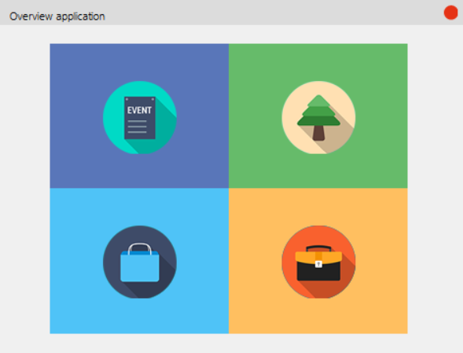

The overview application consists of 4 main tiles:

1. Event overview
2. Camps overview
3. Shops overview
4. Staff overview

Hover over the tiles will show their functions; clicking on one of them will show a corresponding window for that section.

*Event overview*

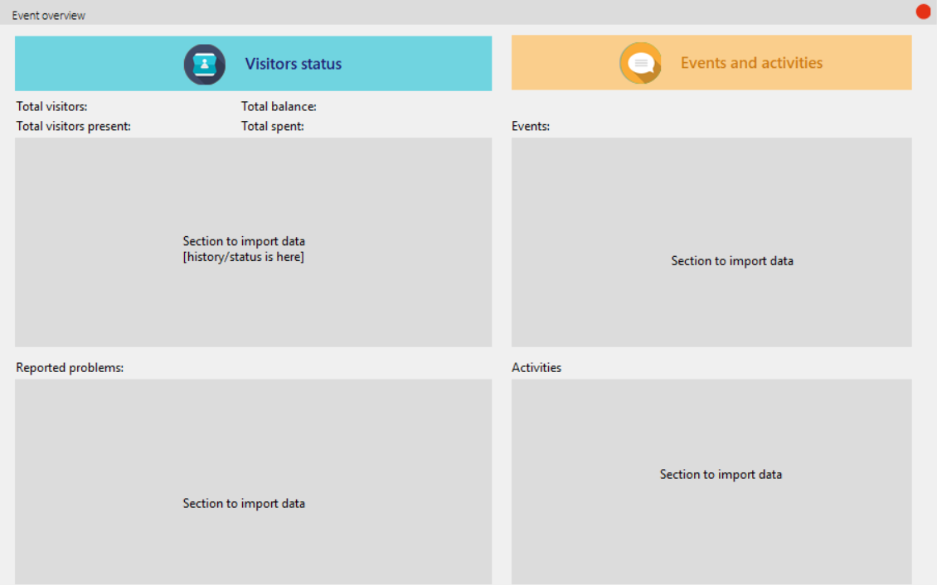

1. Visitors status

The information about the visitors and the activities within the event is shown here.

This section will have its data imported from a database, which will contain information about all the visitors currently present.

The section ‘Reported problems’ will show the issues which visitors have reported and whether or not they have been resolved.

1. Events and activities

This section will have its data imported from a database, which will contain the time and location for current and/or upcoming events and activities.

1. Backend processes

Here is how information will be retrieved for the Visitor’s Status section:

* In the visitors table, a visitor’s personal information is stored. Besides that, the following information is also stored: status (checked in or out), the time checked in and out, the card’s id to which the visitor is linked, the balance on said card and the money spent on said card.
* “Total visitors” – Retrievable by a simple total count of all records present in the visitors table.
* “Total visitors present” – Retrievable by a count of all records in the visitors table with the status checked in.
* The visitors table will be displayed in the grey area, which allows the user to see the status of all visitors and the history of who have checked in or out.
* “Total balance” – Retrievable by a sum of all balance from visitors.
* “Total spent” – Retrievable by a sum of all spent money from visitors.
* “Reported problems” – There will be a separate table to store this. The following information is kept: problem description, the date, the location and the status of the problem.

Here is how information will be retrieved for the Events and Activities section:

* The following information is kept for both events and activities in separate tables: name, date, time and location. The respective tables will be displayed.

*Camp overview*

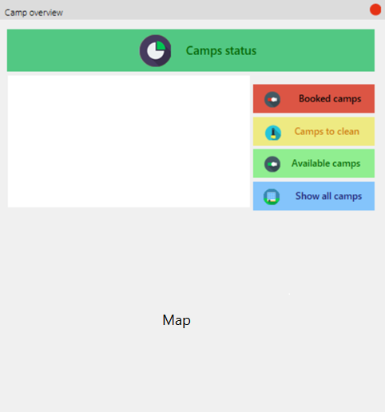

1. Camp status

Once user clicks on one of the buttons, the corresponding information will be shown on a listbox to the left.

The section for the map will display the campsite’s map with symbols marking the camps as well as their status.

1. Back-end processes

For camps, the following information is kept: their name, their location, their status (booked, available or needed servicing). We can retrieve information for this section by querying the status of the camps.

The map will be an overview of all camps and then on the map itself, there will be symbols (circles, triangles, etc) to indicate their status.

*Shop overview*

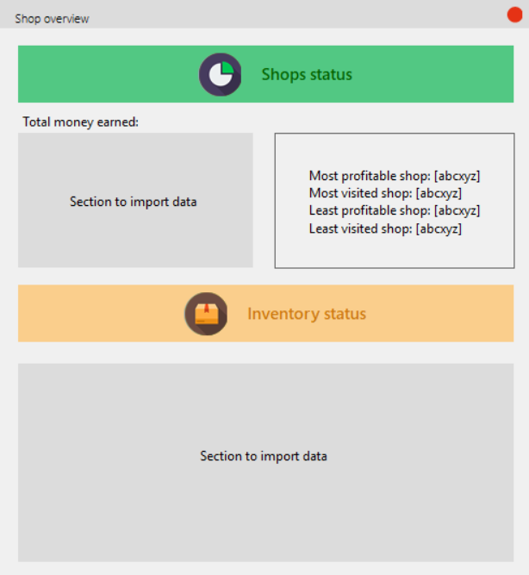

1. Shop status

The total money earned by shop will be shown via a query from the database, which will be imported in the corresponding section.

Retrieving information in the database, we can also display a ranking of shops in the section to the right.

1. Inventory status

Inventory status will have its data imported from a database, showing all the items currently in stock and those which will need to be restocked soon.

1. Back-end processes

For shops, the following information is kept: their name, their location, the total number of visits and the total money earned. The total money earned will be increased accordingly every time a customer purchases goods from the shop.

This table will be displayed in the imported data section. From this table, we can also have more interesting queries such as the most profitable shops, the least profitable shops, etc.

*Staff overview*

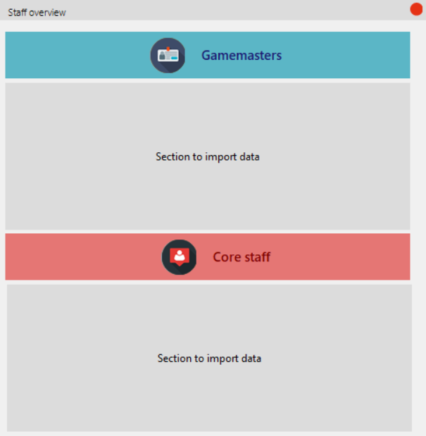

1. Gamemasters

LARP Events consist of gamemasters located all around the terrain to aid players with their experience. This section will show the gamemasters’ information as well as location.

1. Core staff

This section will show information as well as the location of all the staff who are not gamemasters.

1. Back-end processes

For staff, the following information is kept: their personal details, their function as well as their assigned location.

The gamemasters’ data can be retrieved by querying the staff table for those who have their status as “Gamemasters” and then display the results of that query here.

The core staff’s data can be retrieved by querying the staff table for those who are not gamemasteres and then display the results of that query here.

**Entrance of event**

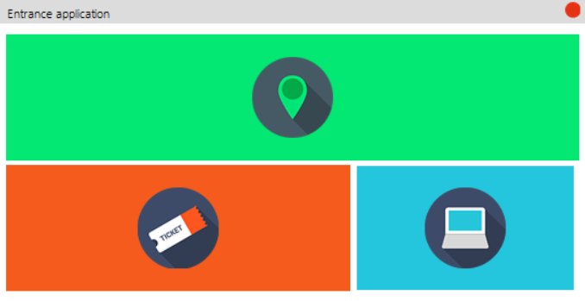

The entrance application consists of 3 main tiles:

1. Check in
2. Check out
3. Monitor visitors

Hover over the tiles will show their functions; clicking on one of them will show a corresponding window for that section.

*Check in*

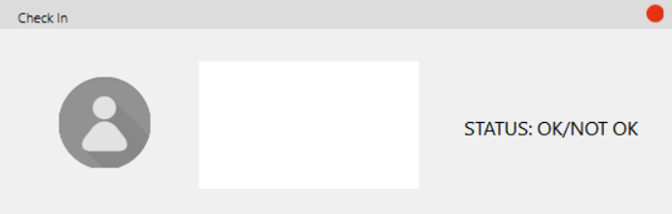

1. Front-end processes

Once a visitor scans their ticket, their details will show up in the listbox, as well as their picture. If the linking has been successfully performed, the status will appears accordingly.

1. Back-end processes

On our website, a potential visitor has to fill out their information to register for an account. Once they have an account, they can choose to purchase a ticket or not. This means that in the database, we do have information of potential visitors and actual visitors.

In the database, the actual visitors will have a QR code assigned to them as they have purchased a ticket whereas the potential ones will not. Once a visitor scans their ticket, the visitor’s personal information will be retrieved from a database by checking the scanned QR code:

* If the QR code matches – the visitor has purchased a ticket: The system will then proceed to assign the first available card’s id. The status on the program will show as ‘OK’ and the visitor’s status in the database will register as checked in.
* If the QR code does not match – the visitor has either not purchased a ticket or a ticket is erroneous: The status will show as ‘Not OK’ and the staff at hand can further process the situation. A possible solution can be that the visitor will purchase a new ticket on the spot or they can show the staff their proof of payment.

*Check out*

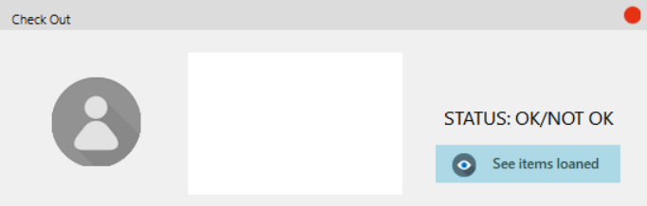

1. Front-end processes

Once a visitor scans their ticket, their details will show up in the listbox, as well as their picture. If they have unreturned item(s), their status will show up as “NOT OK” and the item(s) which they have not returned will show up in the listbox; otherwise, their status will be “OK” and they are free to leave.

**See items loaned**: Display all the items not returned from the events (regardless of who has not returned them)

1. Back-end processes

If a visitor loans an item, their unique ID will be kept together with the loaned item’s ID, the loan date, the return date and status (returned or not). These are loaning records.

Once the visitor scans their ID, the application will receive the visitor’s unique ID in the database. From this ID, the database can count all loaning records where the visitor’s ID is present and the status is not returned.

* If there are no rows matching such a requirement – meaning the visitor has either not borrowed anything or they have returned all items: the visitor is free to leave and the status will show as ‘OK’.
* If there are one or more rows matching such a requirement – meaning the visitor has unreturned item(s): the information retrieved from the aforementioned query will be shown in the listbox and the status will show as ‘Not OK’.

“See items loaned” – This information is retrieved by performing a query on the database asking for all loaning records whose status are not returned.

*Monitor visitors*

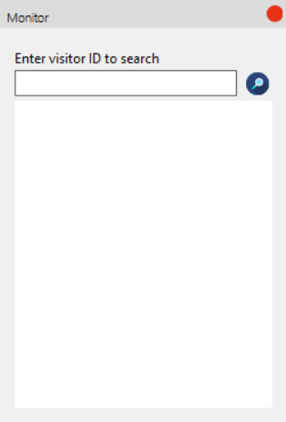

1. Front-end processes

The staff can enter a visitor ID to search, clicking on the magnifying glass will show their details in the listbox.

1. Back-end processes

Every visitor has their own unique ID kept in the database and all their personal details are linked to this ID. The database can perform a simple query to see if the entered visitor ID exists in the database:

* If it does: the information from this query will be shown in the listbox.
* If it does not: the visitor is not registered in the event and an appropriate message box will be shown.

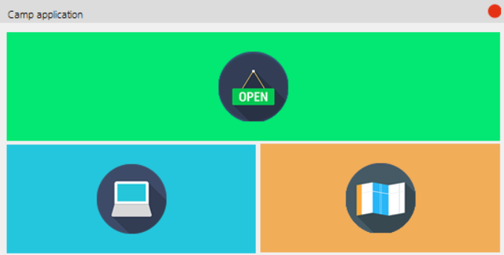**Entrance of campsite:**

The entrance application consists of 3 main tiles:

1. Check in
2. Monitor reservations
3. Camp status

Hover over the tiles will show their functions; clicking on one of them will show a corresponding window for that section.

*Check in*

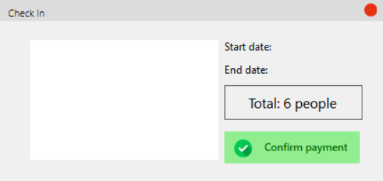

1. Front-end processes

After the user has scanned their ID, their group’s information will show up in the listbox, together with the start date and end date of their reservations. The total number of people will also be updated.

Once the payment process has been sorted out, clicking on **Confirm payment** will greenlight the group’s status and they are checked in.

1. Back-end processes

In the database, every reservation has its own unique ID together with the visitor’s ID as well as the camp’s ID. These are reservation records. The status for the reservation is also kept (paid or unpaid) and is unpaid by default.

Once a visitor scans their ID, the application will receive the visitor’s unique ID and then proceed to query the database to see if that ID is present in any reservation records.

* If there is a reservation for said visitor: Everyone who shares the same reservation will have their information shown in the listbox. Clicking on **Confirm payment** will change the status of the reservation from unpaid to paid.
* If there isn’t a reservation matched: An appropriate message box will show to notify the staff.

*Monitor reservations*

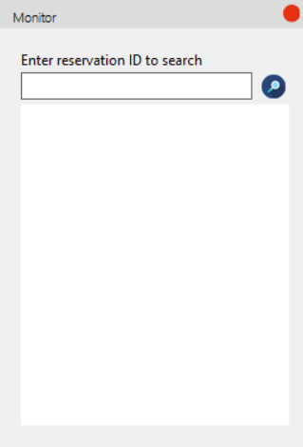

1. Front-end processes

The staff can enter a reservation ID to search, clicking on the magnifying glass will show their details in the listbox.

1. Back-end processes

Every reservation has its own unique ID kept in the database and all its details are linked to this ID. The database can perform a simple query to see if the entered reservation ID exists in the database:

* If it does: the information from this query will be shown in the listbox.
* If it does not: the reservation is not registered in the event and an appropriate message box will be shown.

*Camp status*

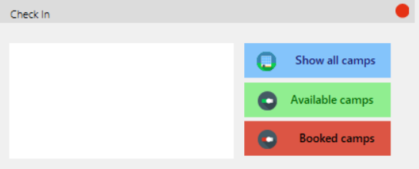

1. Front-end processes

Once user clicks on one of the buttons, the corresponding information will be shown on a listbox to the left. .

1. Back-end processes

For camps, the following information is kept: their name, their location, their status (booked, available or needed servicing). We can retrieve information for this section by querying the status of the camps.

In this case: the personel is restricted to seeing only available or booked camps as they are working at the entrance of the camps and do not need to be concerned with which camps need to be serviced.

**Store application**

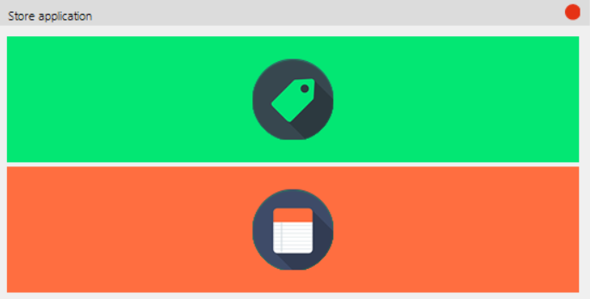

The store application consists of 2 main tiles:

1. See products – to display all products available
2. See cart – to display products which the user has selected

Hover over the tiles will show their functions; clicking on one of them will show a corresponding window for that section.

*See products*

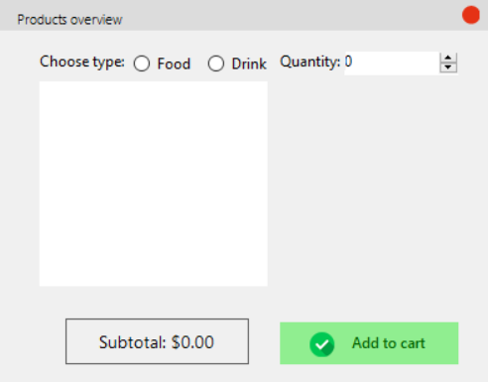

1. Front-end processes

User will choose their type of products: Food or Drink. The available products for their respective choice will display as they click on the radio button.

If they select an item in the listbox, the picture of said item will show up in the area to its right. The picture will change if the user selects one item. If the user selects multiple items, the images will not display.

Once they have selected their item(s), the user can increase or decrease the quantity to order.

The subtotal will automatically update as the user interacts with the software.

**Add to cart:** Once they are sure that they want certain products, they can click on this button to add them to their order

1. Back-end processes

For items in stores, the following information is kept: their name, their price, their type (food or drink) and the file name of their respective image.

Clicking on the radio buttons will query the database for the items of the chosen type and then proceed to display that in the listbox.

If user selects an item from the listbox, the picture’s source will be set to the item’s image file, thereby displaying the appropriate image.

The subtotal is calculated by: the sum of (price x quantity) for all items.

Clicking **Add to cart** will register the chosen item and the input quantity, then add it to a temporary cart created for that shopping session.

*See cart*

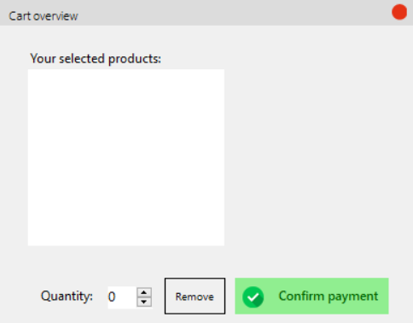

1. Front-end processes

Details about what the user ordered will be displayed in the listbox.

If they select an item in the listbox, the picture of said item will show up in the area to its right. The picture will change if the user selects one item. If the user selects multiple items, the images will not display.

**Remove**: The user has the option to modify the quantity they have ordered earlier and clicking on this button will execute the action.

**Confirm payment**: Clicking on this button will confirm and process the order.

1. Back-end processes

The mechanism for displaying images is the same as above.

Clicking on the **Remove** button will register the entered quantity to remove and update the data accordingly.

Clicking on **Confirm payment** will register the temporary cart session as a new record in the database, marking the transaction as finished. This action will:

* Decrease the visitor’s balance
* Increase the visitor’s total spent
* Increase the shop’s total earned
* Decrease the quantity of products purchased

.

**Store application**

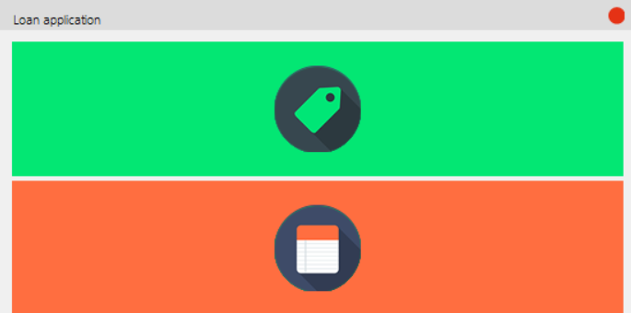

The loan application consists of 2 main tiles:

1. See products – to display all products available
2. See cart – to display products which the user has selected

Hover over the tiles will show their functions; clicking on one of them will show a corresponding window for that section.

*See products*

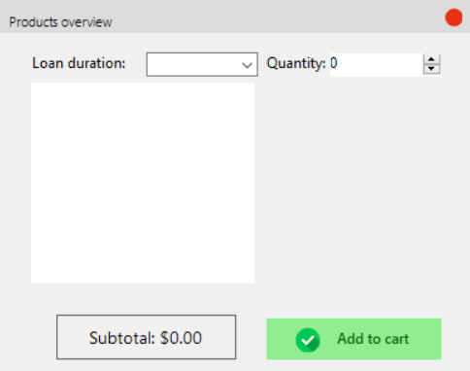

1. Front-end processes

The information about the available items to loan will be shown in the listbox.

If they select an item in the listbox, the picture of said item will show up in the area to its right. The picture will change if the user selects one item. If the user selects multiple items, the images will not display.

The user can select the given loan duration for their item(s) of choice.

Once they have selected their item(s), the user can increase or decrease the quantity to loan.

The subtotal will automatically update as the user interacts with the software.

**Add to cart:** Once they are sure that they want certain products, they can click on this button to add them to their order

1. Back-end processes

For loanable items, the following information is kept: their name, their loaning price and their respective image’s file name.

If user selects an item from the listbox, the picture’s source will be set to the item’s image file, thereby displaying the appropriate image.

Clicking **Add to cart** will register the chosen item, the loan duration and the input quantity, then add it to a temporary cart created for that shopping session.

*See cart*

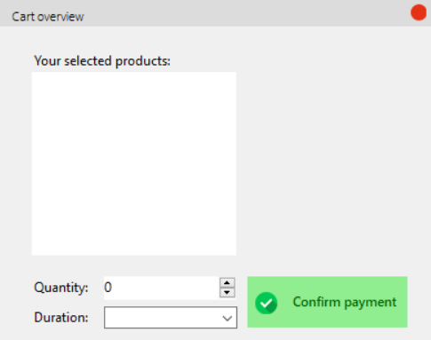

1. Front-end processes

Details about what the user ordered will be displayed in the listbox.

If they select an item in the listbox, the picture of said item will show up in the area to its right. The picture will change if the user selects one item. If the user selects multiple items, the images will not display.

If the user wants to modify the quantity or the duration of their loan, they can select item(s) in the listbox and modify the values of the given input forms.

**Confirm payment**: Clicking on this button will confirm and process the order.

Back-end processes

The mechanism for displaying images is the same as above.

The loan duration will be used by the database to register the deadline for returning the borrowed item. Going over this deadline may result in a fine.

Clicking on **Confirm payment** will register the temporary cart session as a new record in the database, marking the transaction as finished. This action will:

* Decrease the visitor’s balance
* Increase the visitor’s total spent
* Increase the shop’s total earned
* Decrease the quantity of products loaned

# ERD

* **Red**: The core entities.
* 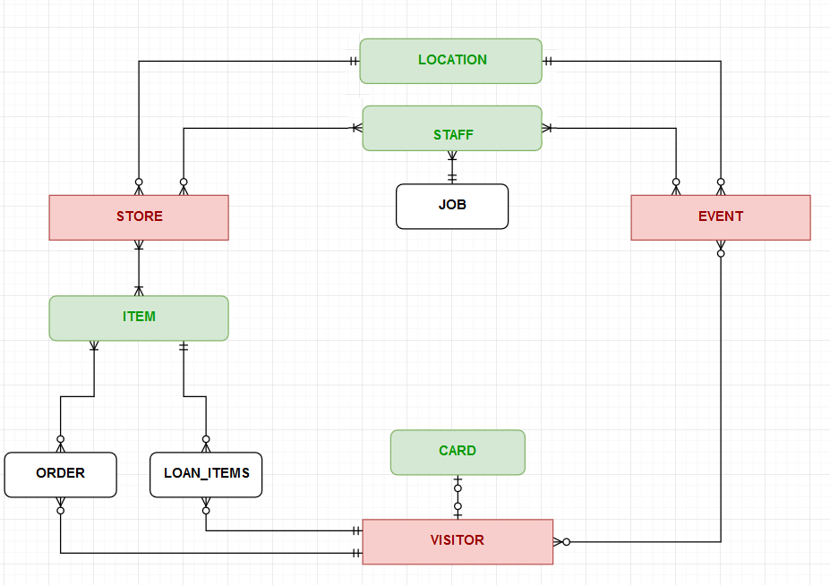**Green**: The entities supporting the core ones.
* **Black**: The entities supporting implementation.

# Wireframes

**Homepage:**

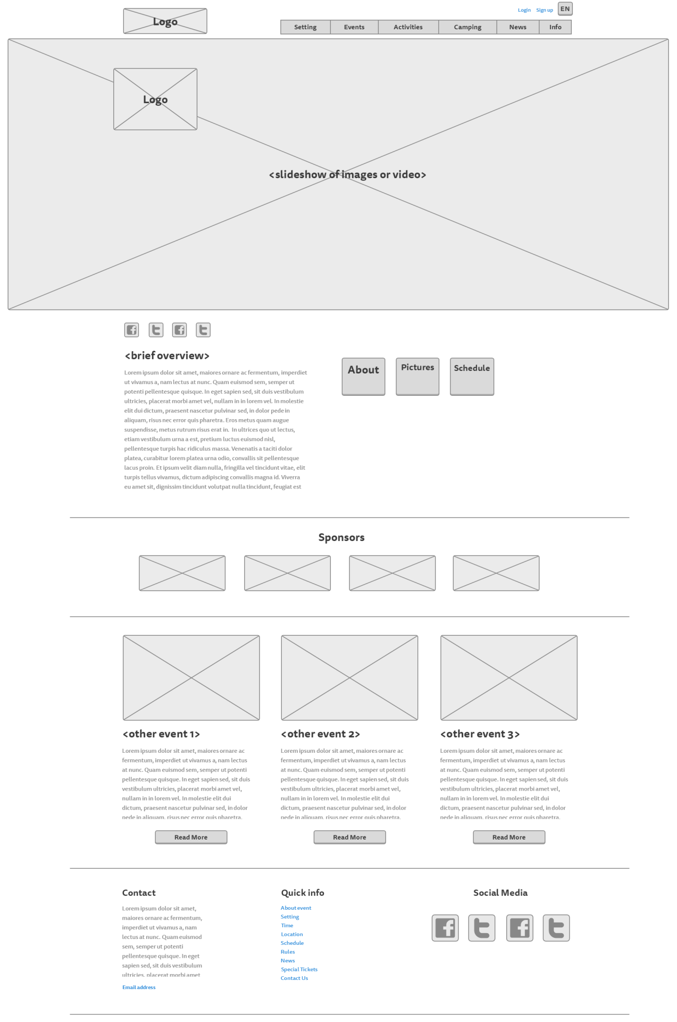

**Setting page:**

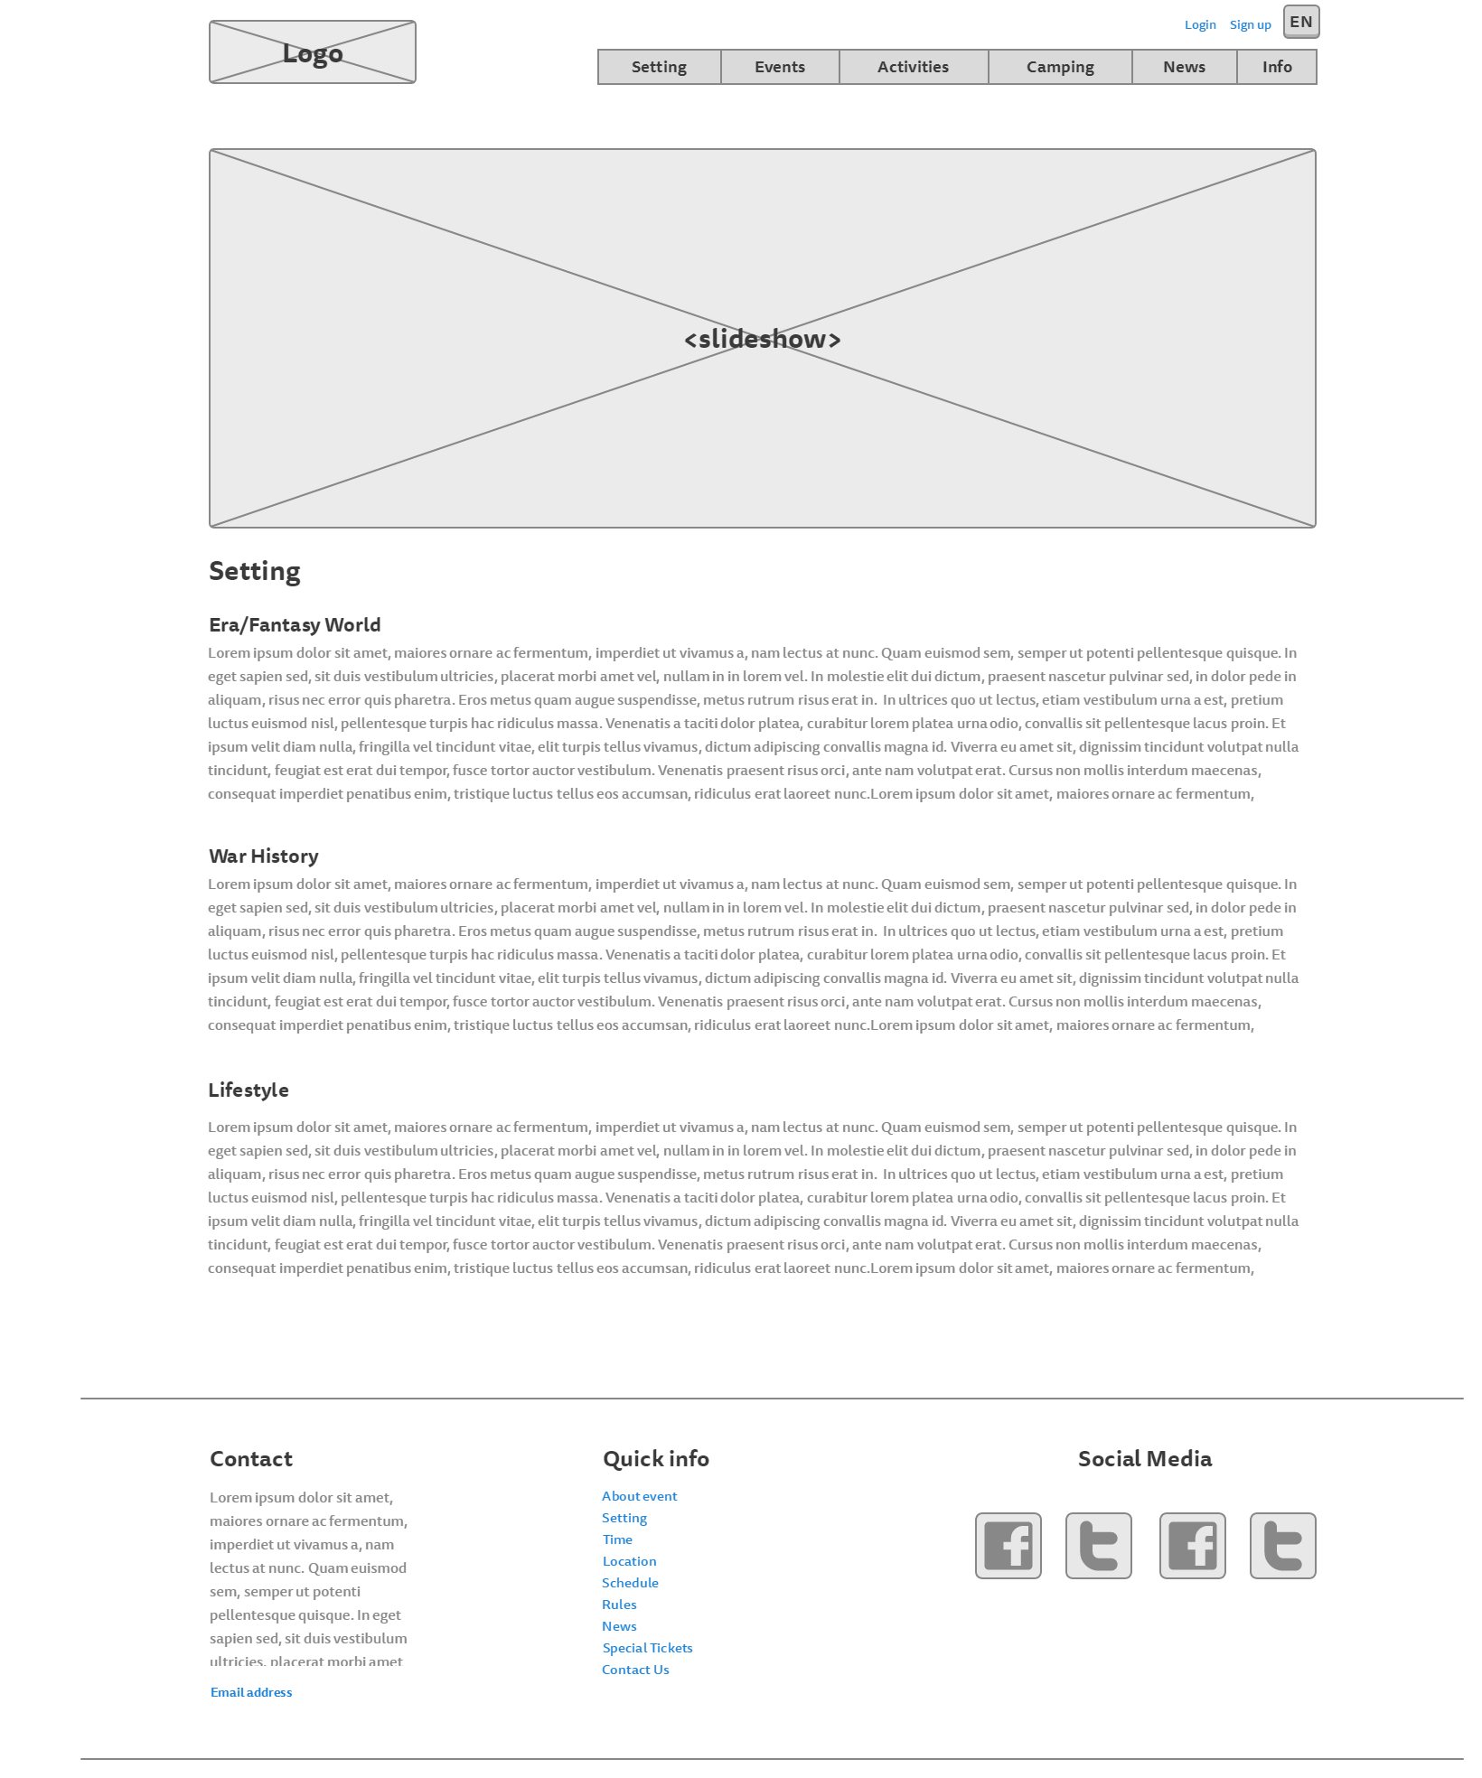

**Rules page:**

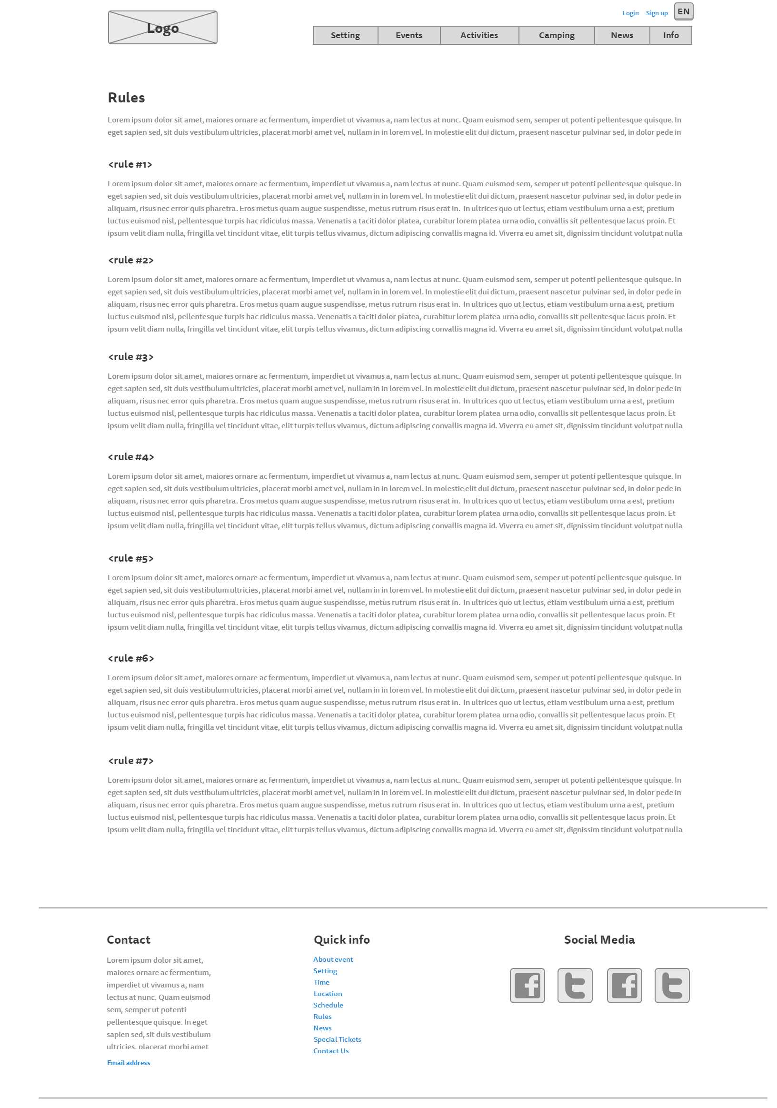

**Events page**

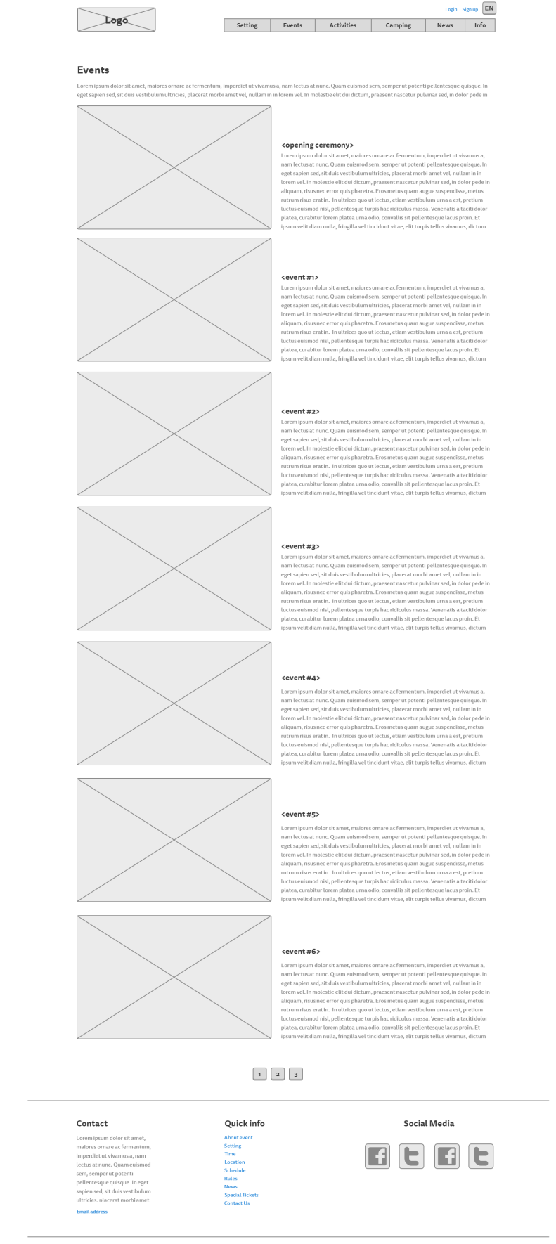

**Activities page:**

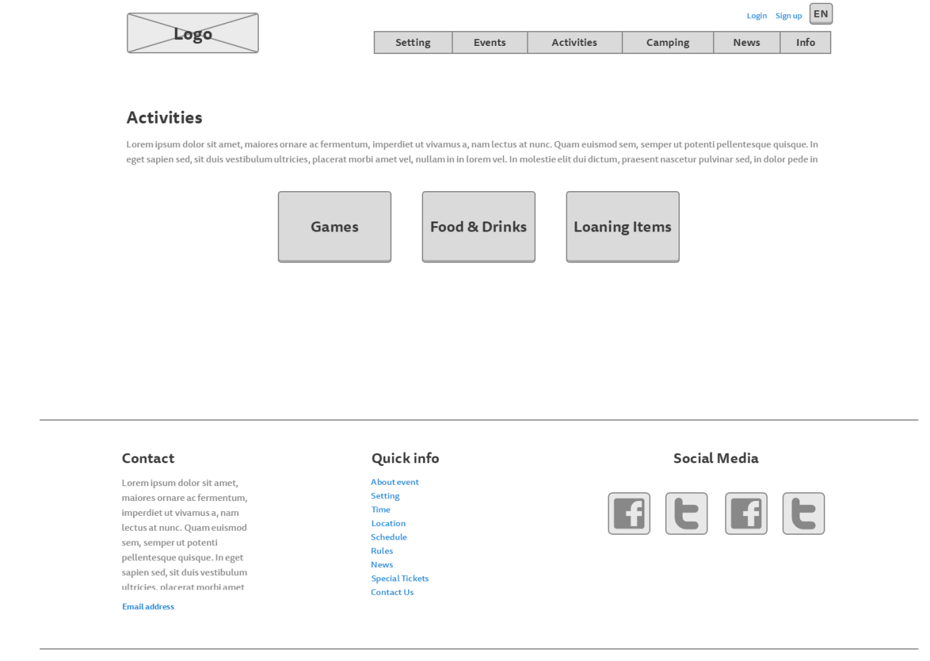

**Food, drinks and loaning items page**

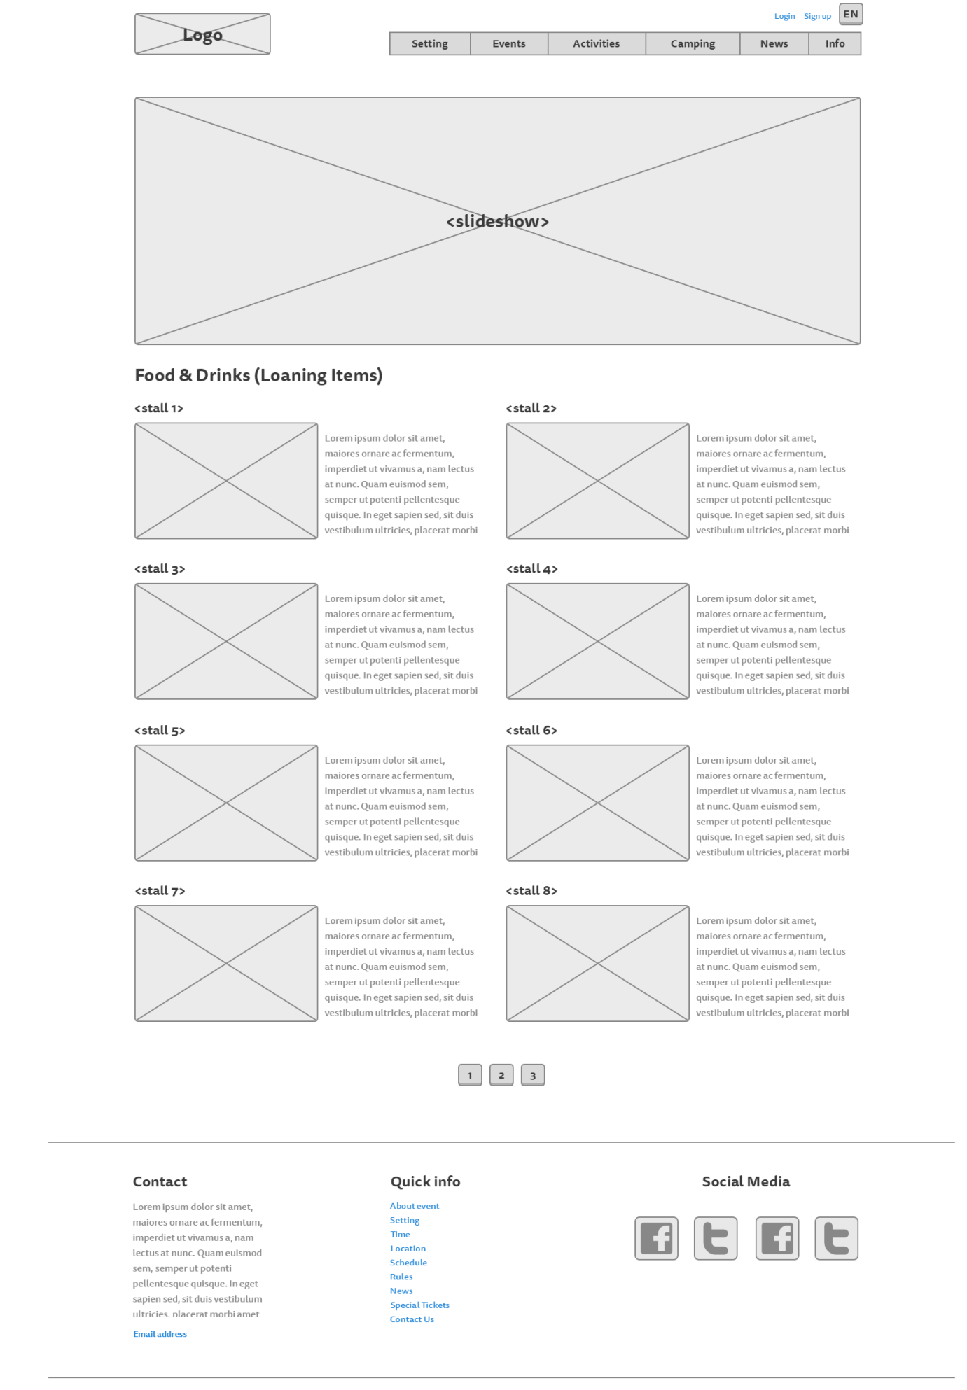

**Games page:**

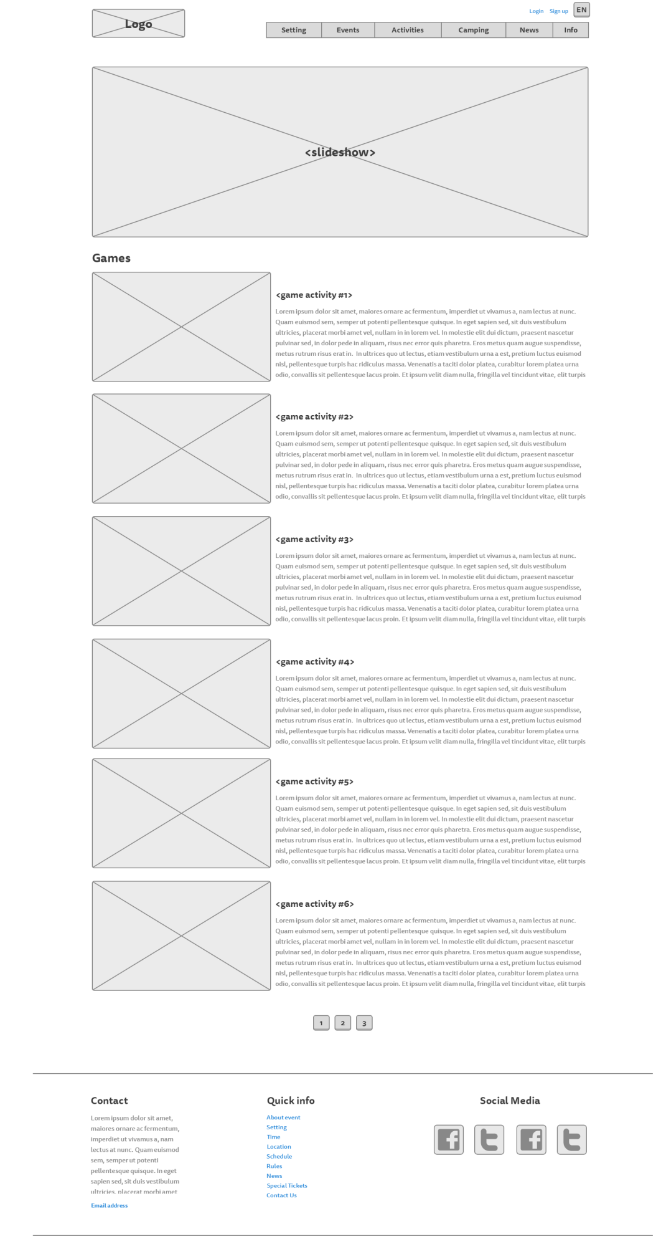

**Camping page:**

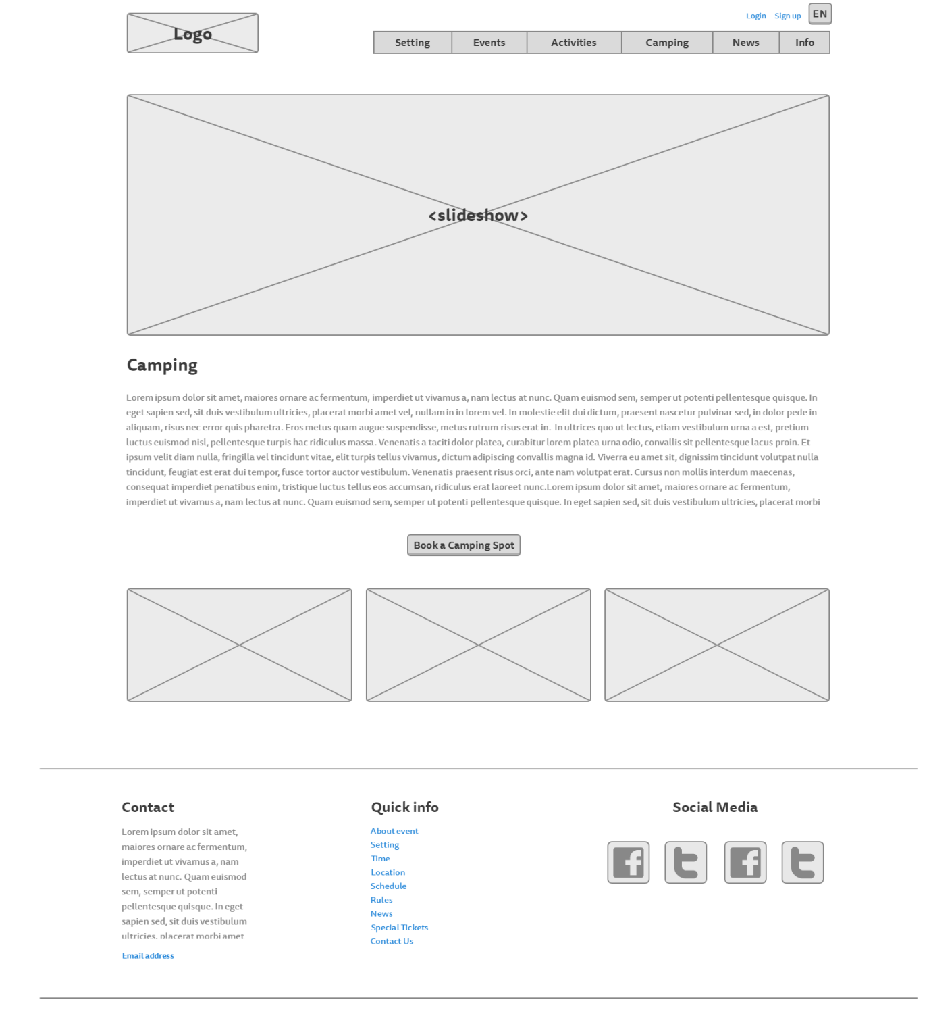

**News page:**

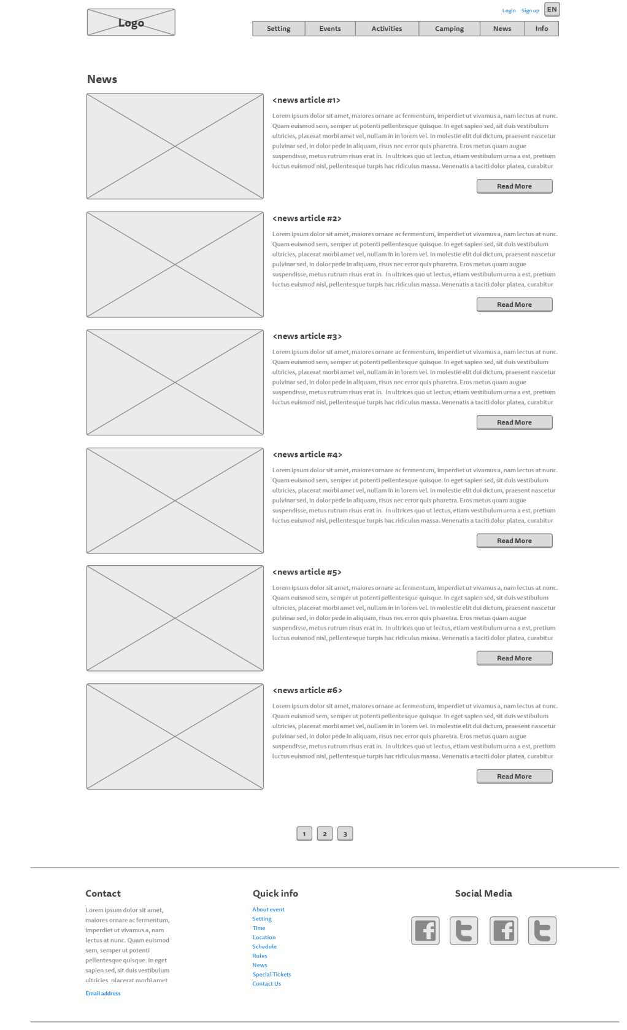

*News – read more:*

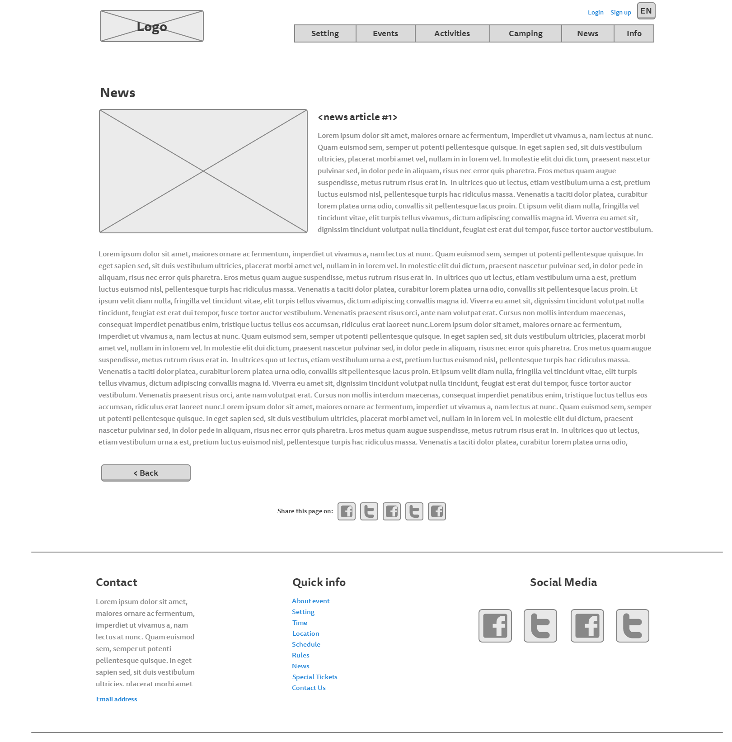

**About page:**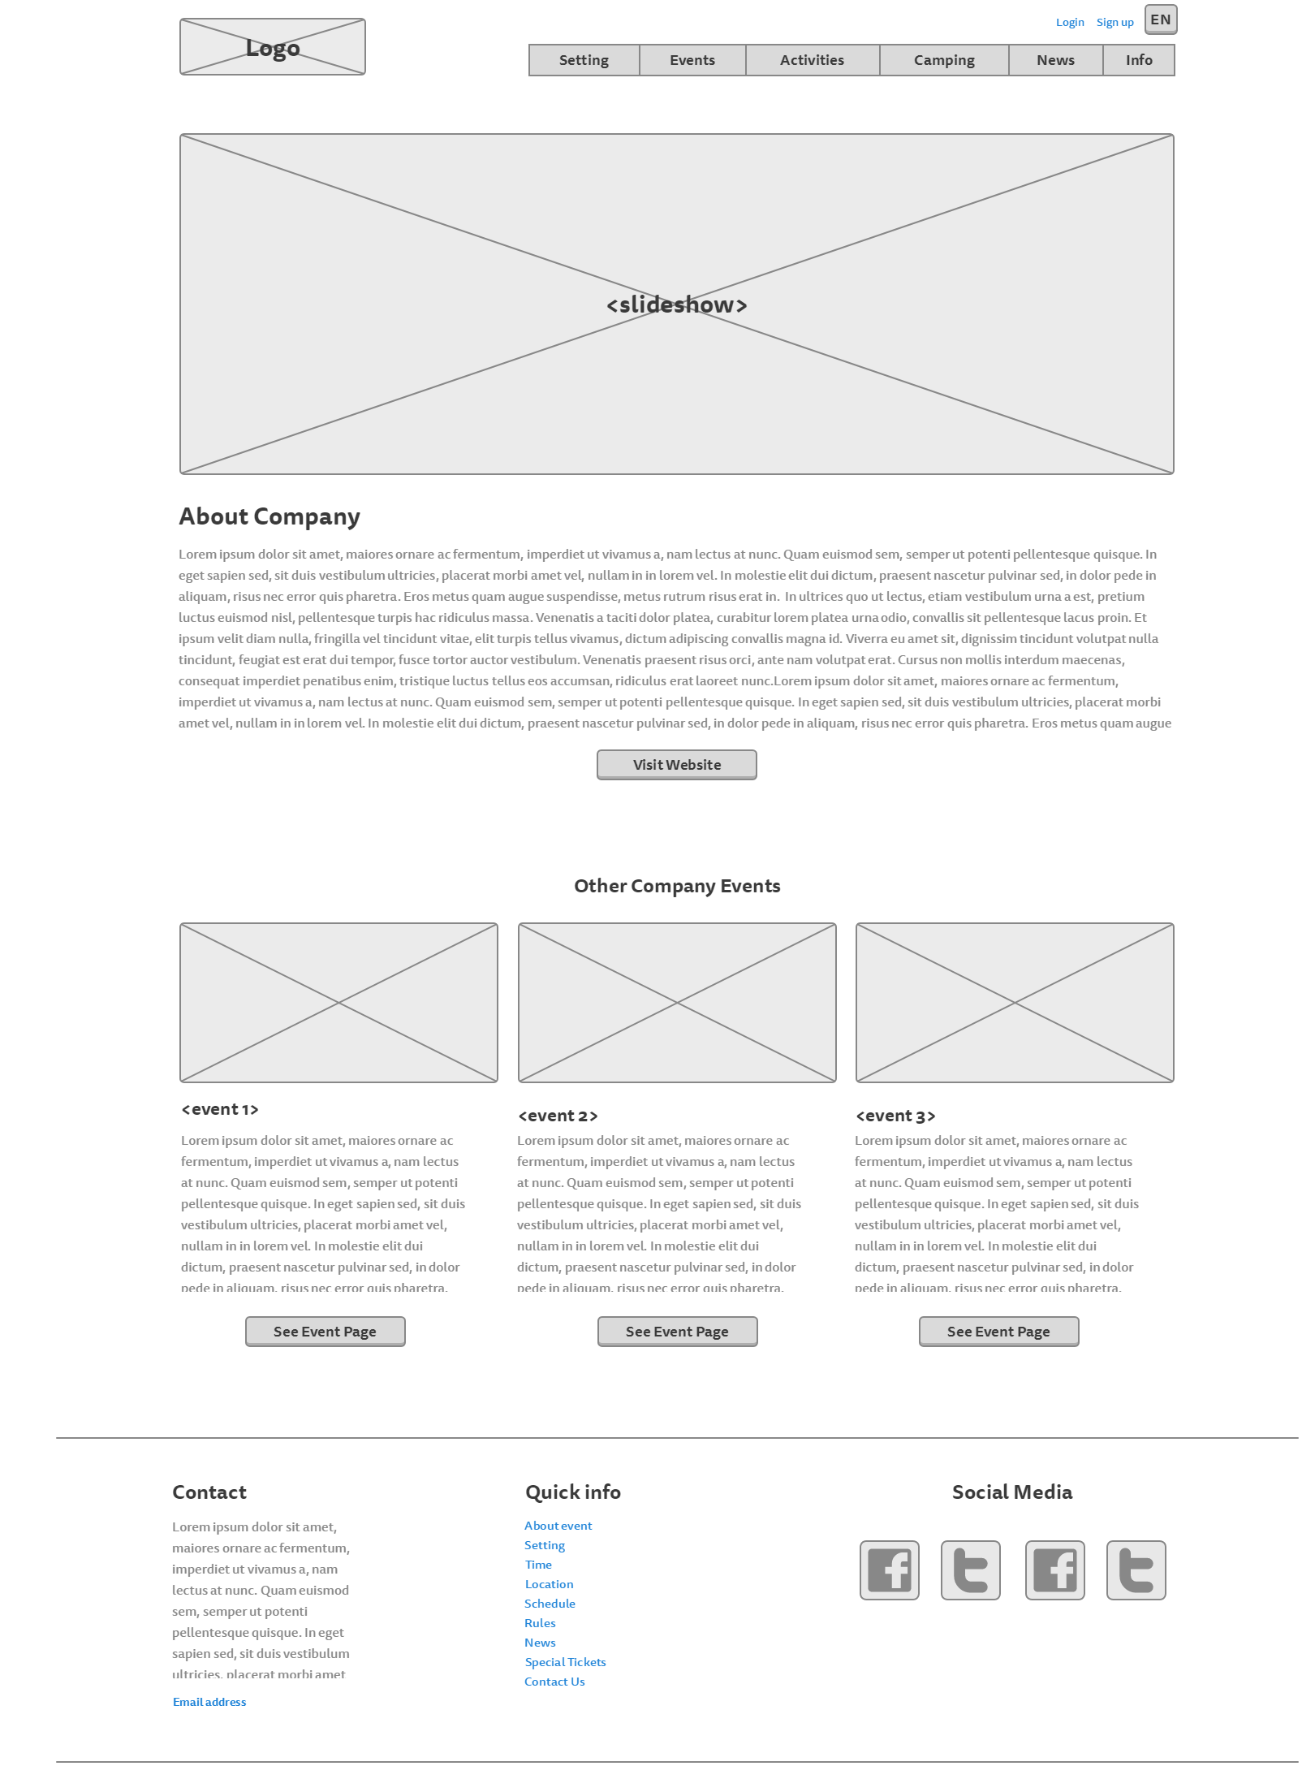

**Login page:**

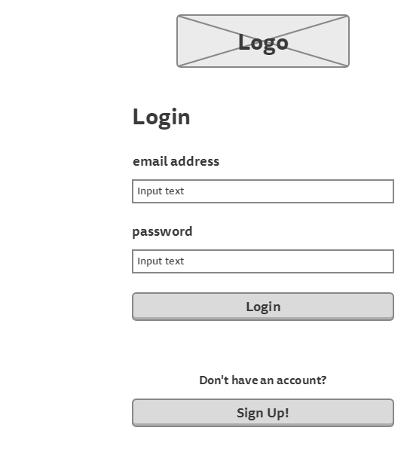

**Sign up page:**

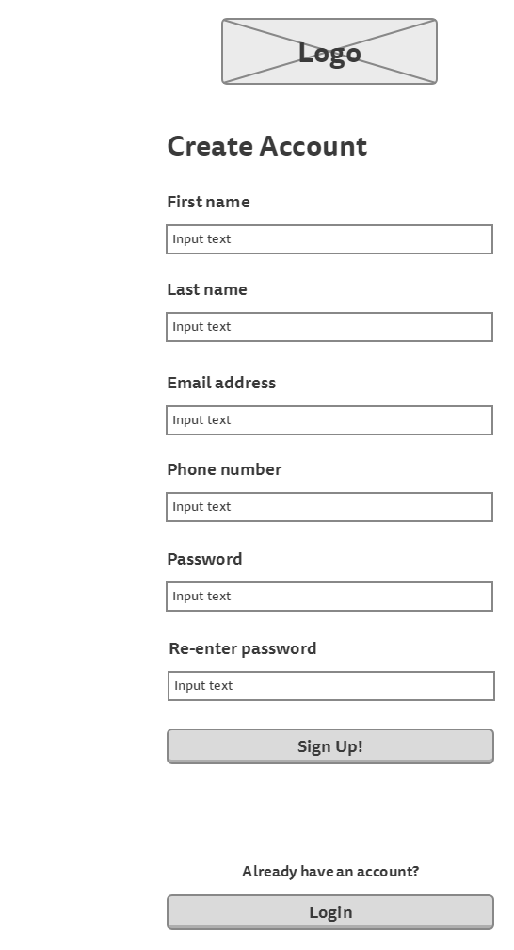

**Participant’s information page** (to show tickets information)

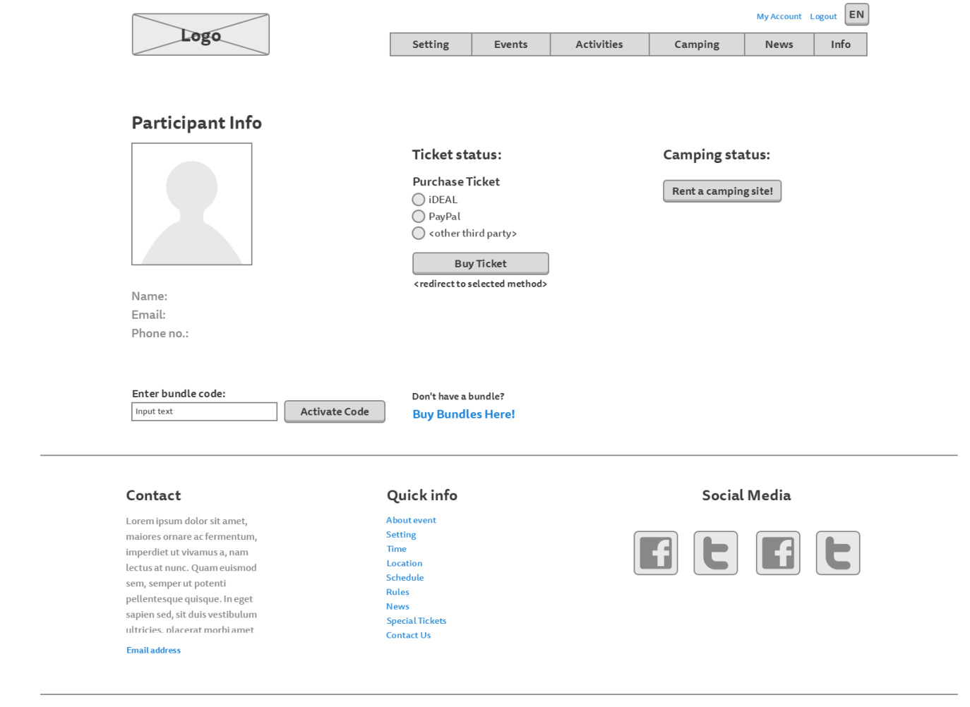

**Participant’s information page** (to show camping information)

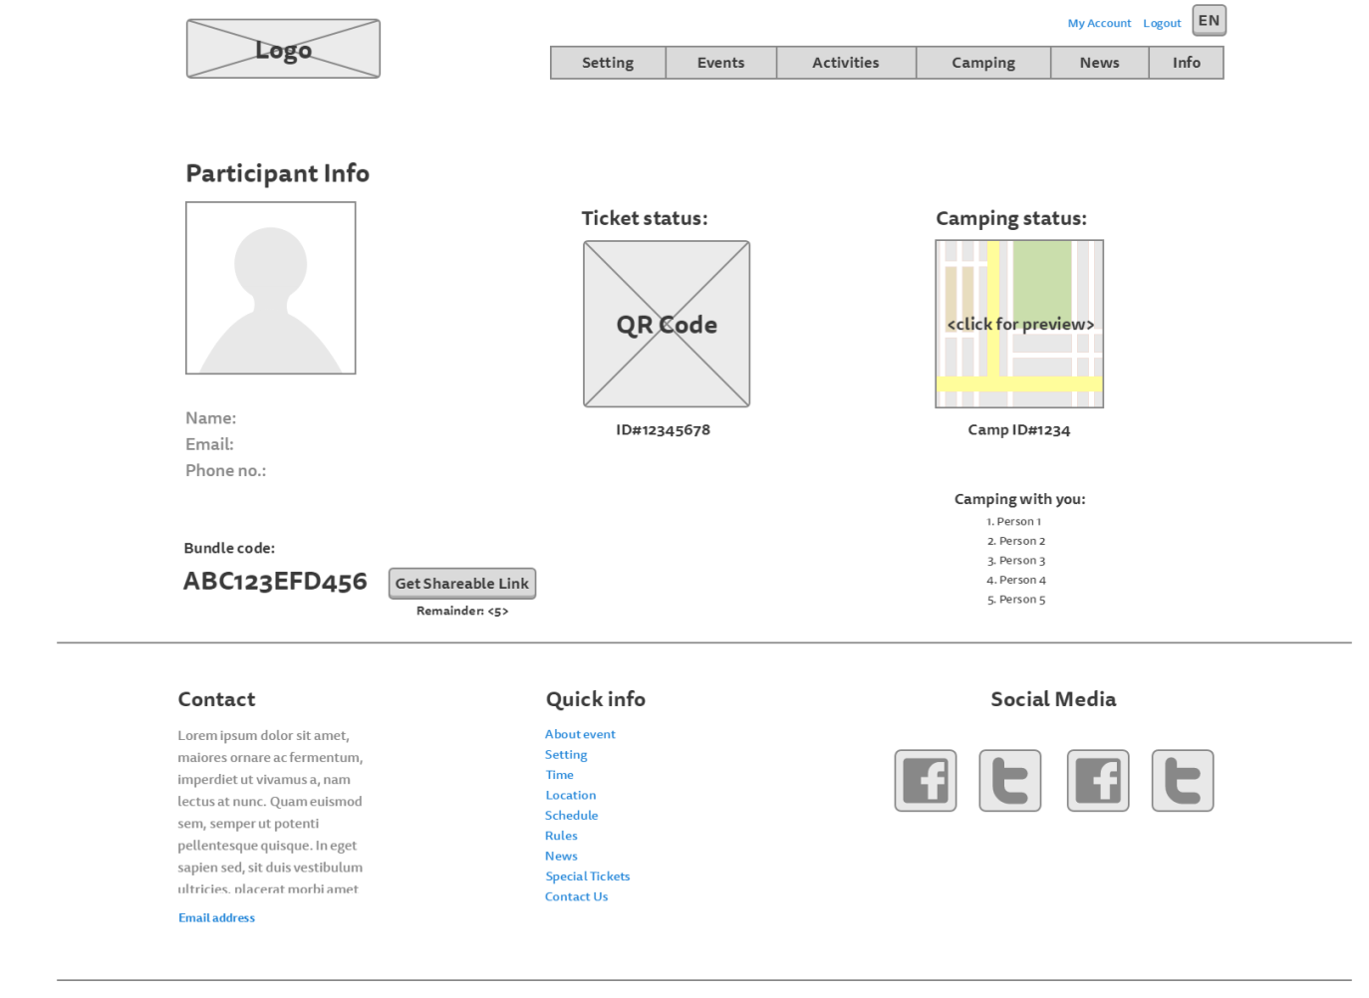

**Camping registration page:**

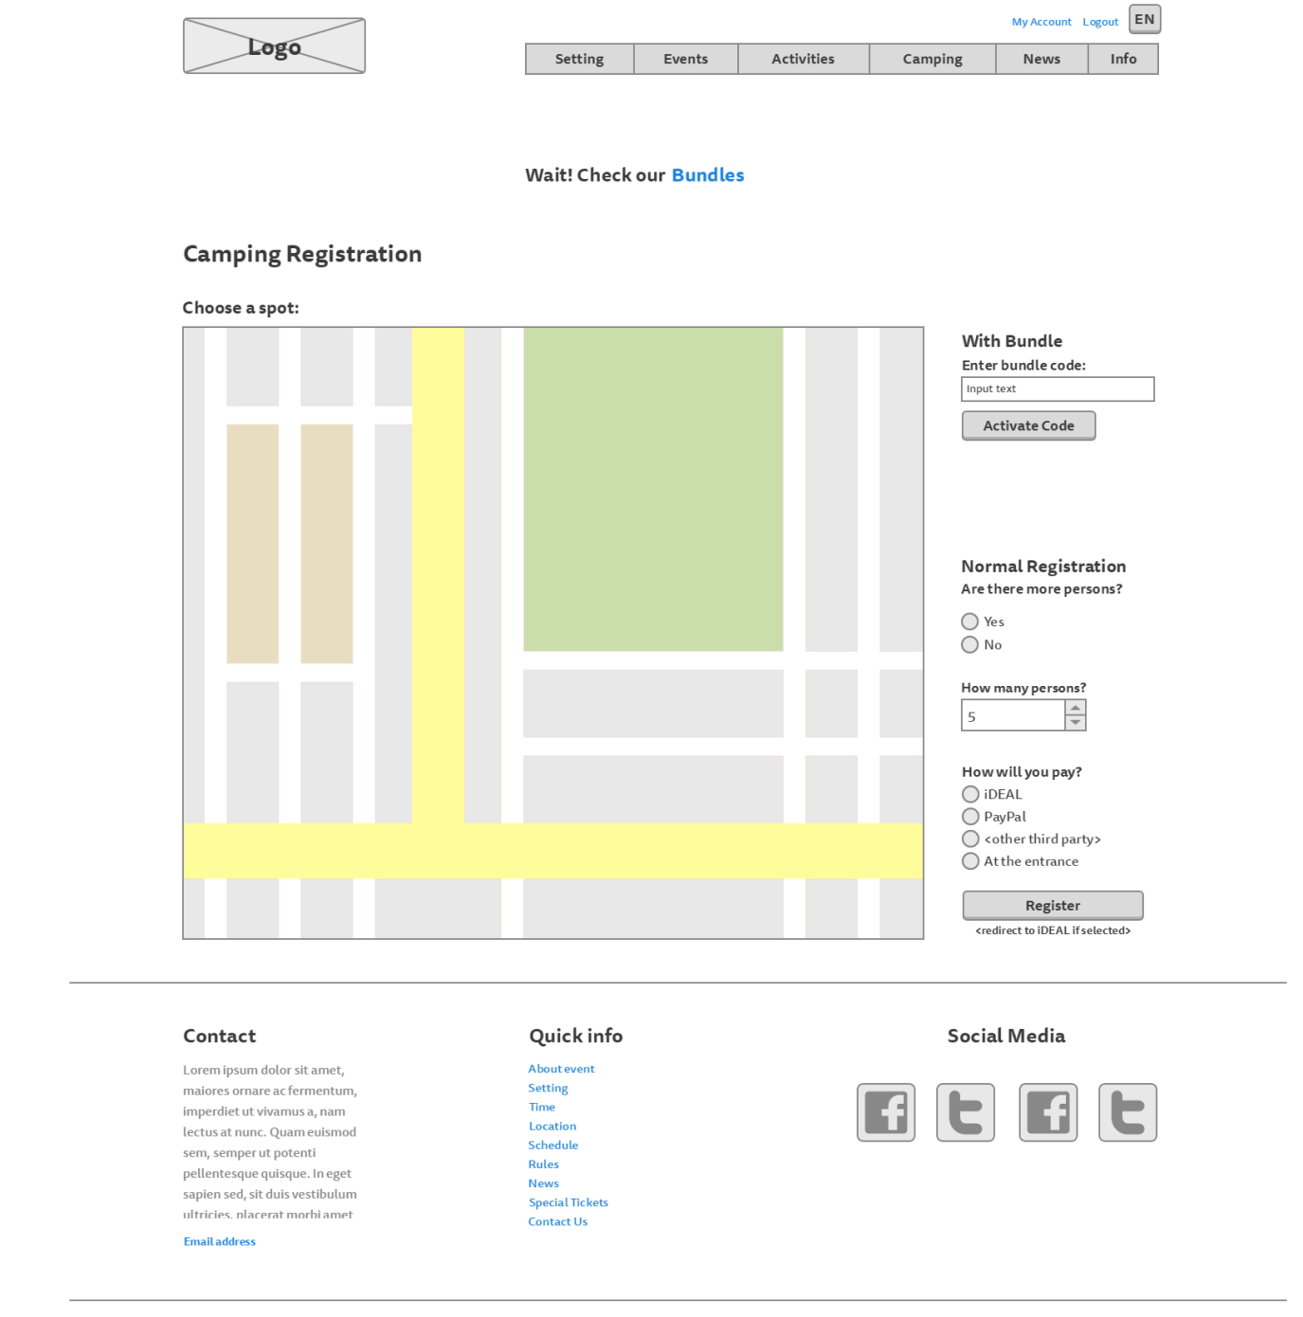

**Bundles page:**

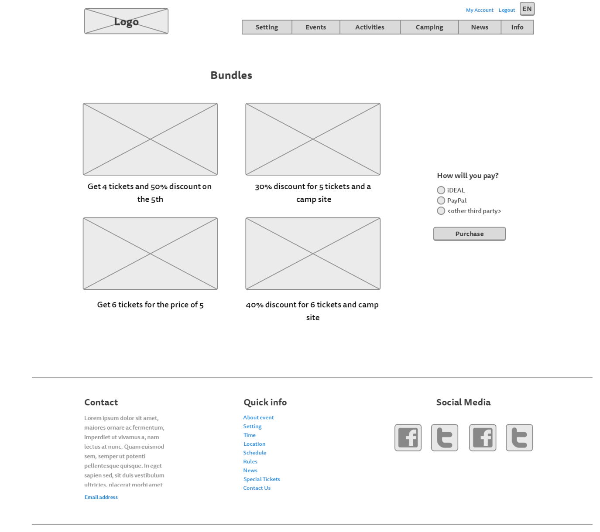

# Visual Design

**Homepage:**

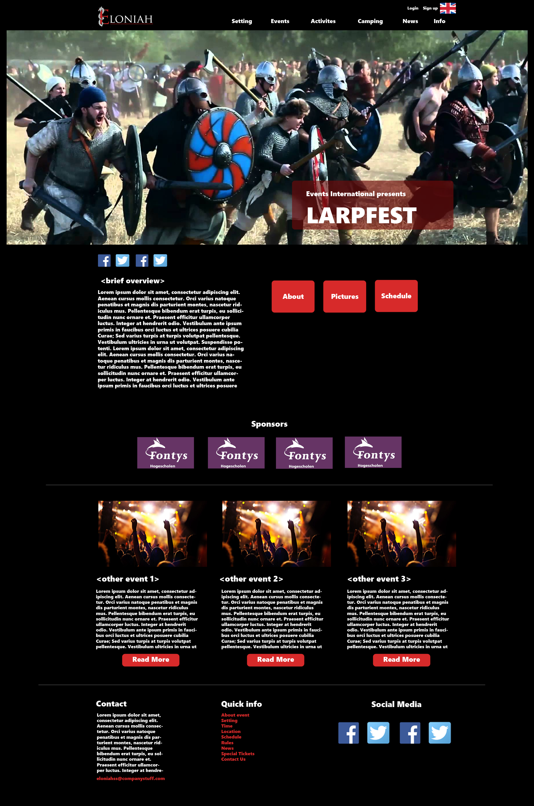

**Setting page:**

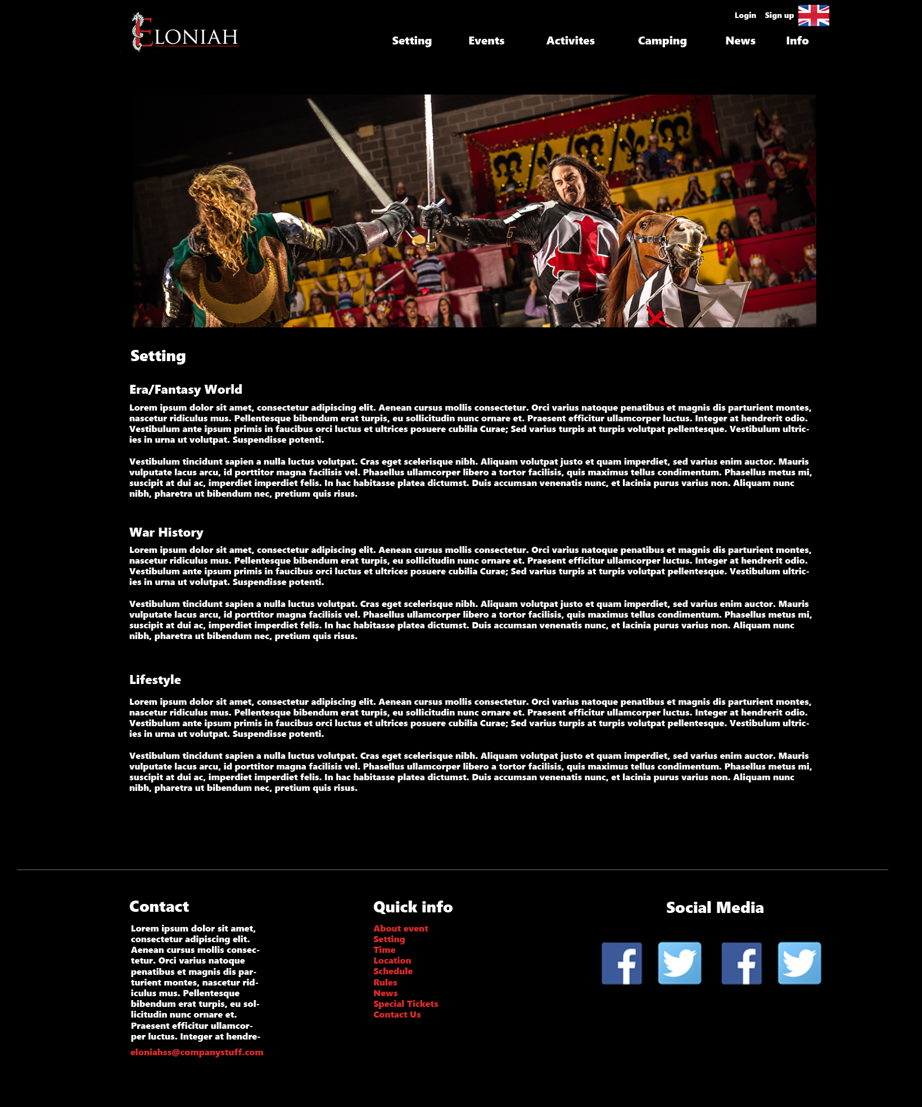

**Rules page:**

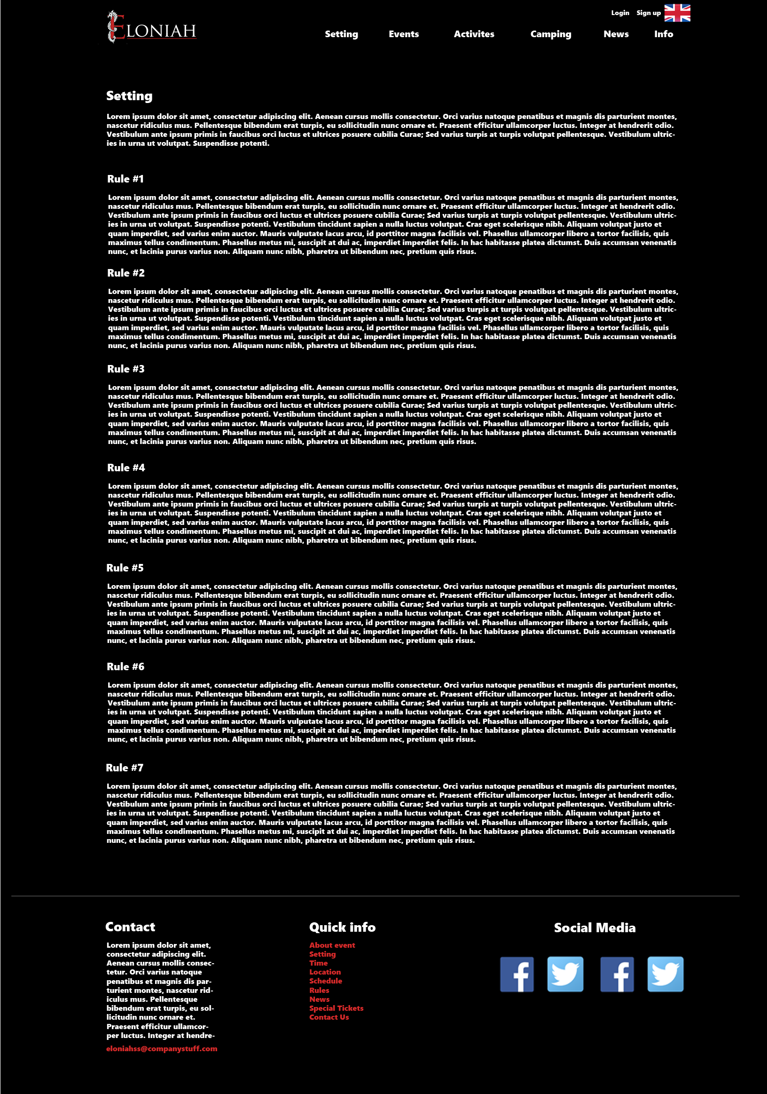

**Events page**

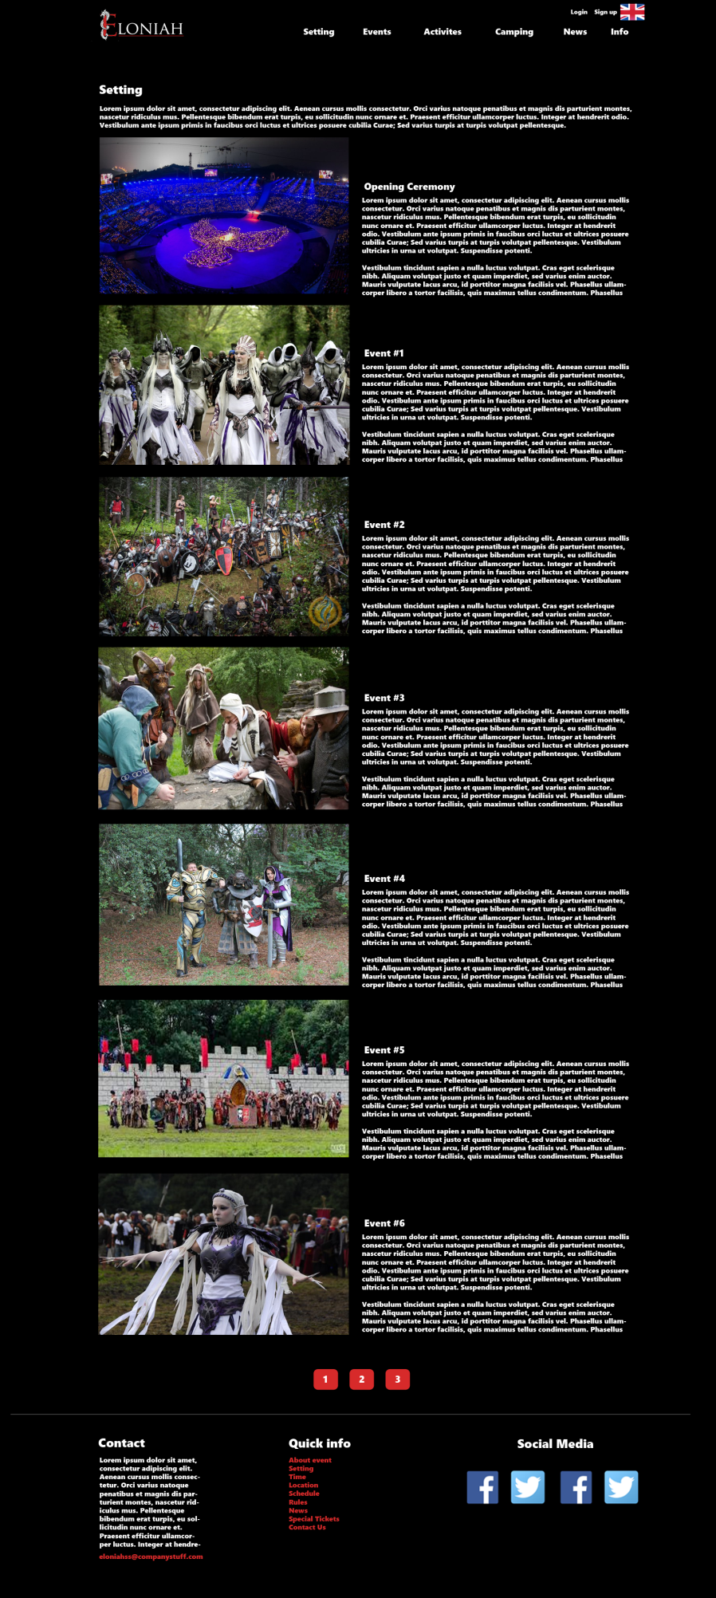

**Activities page:**

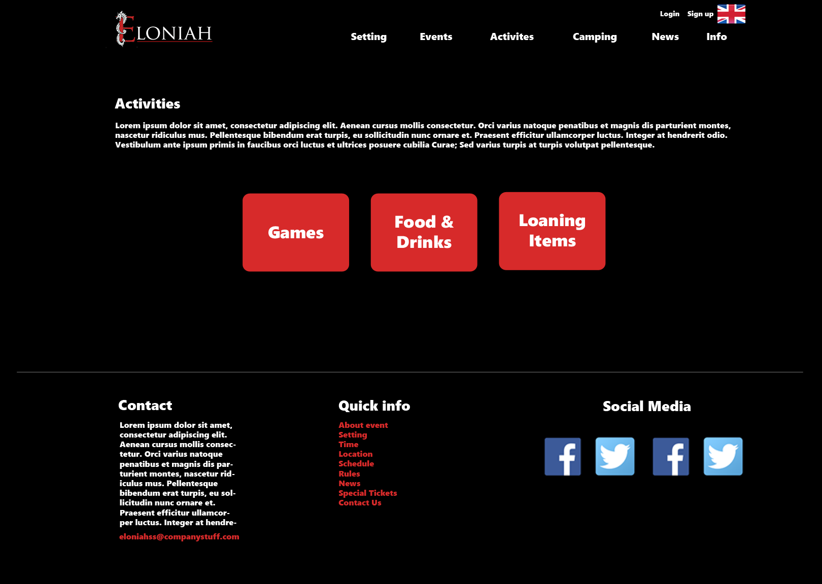

**Food, drinks and loaning items page**

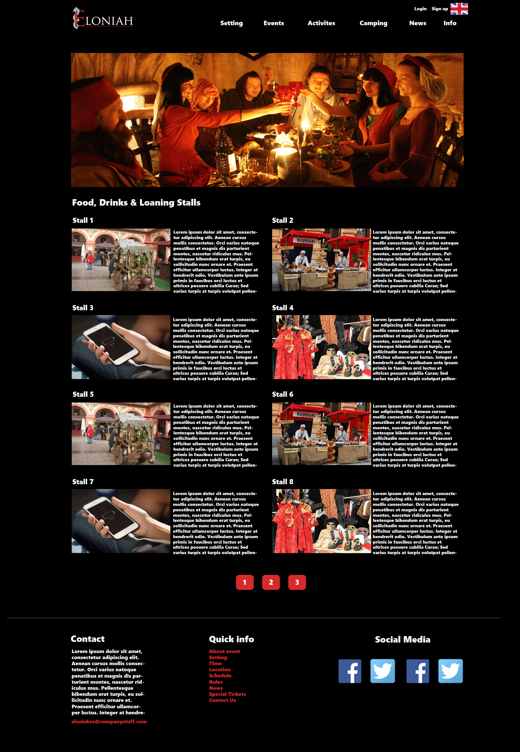

**Games page:**

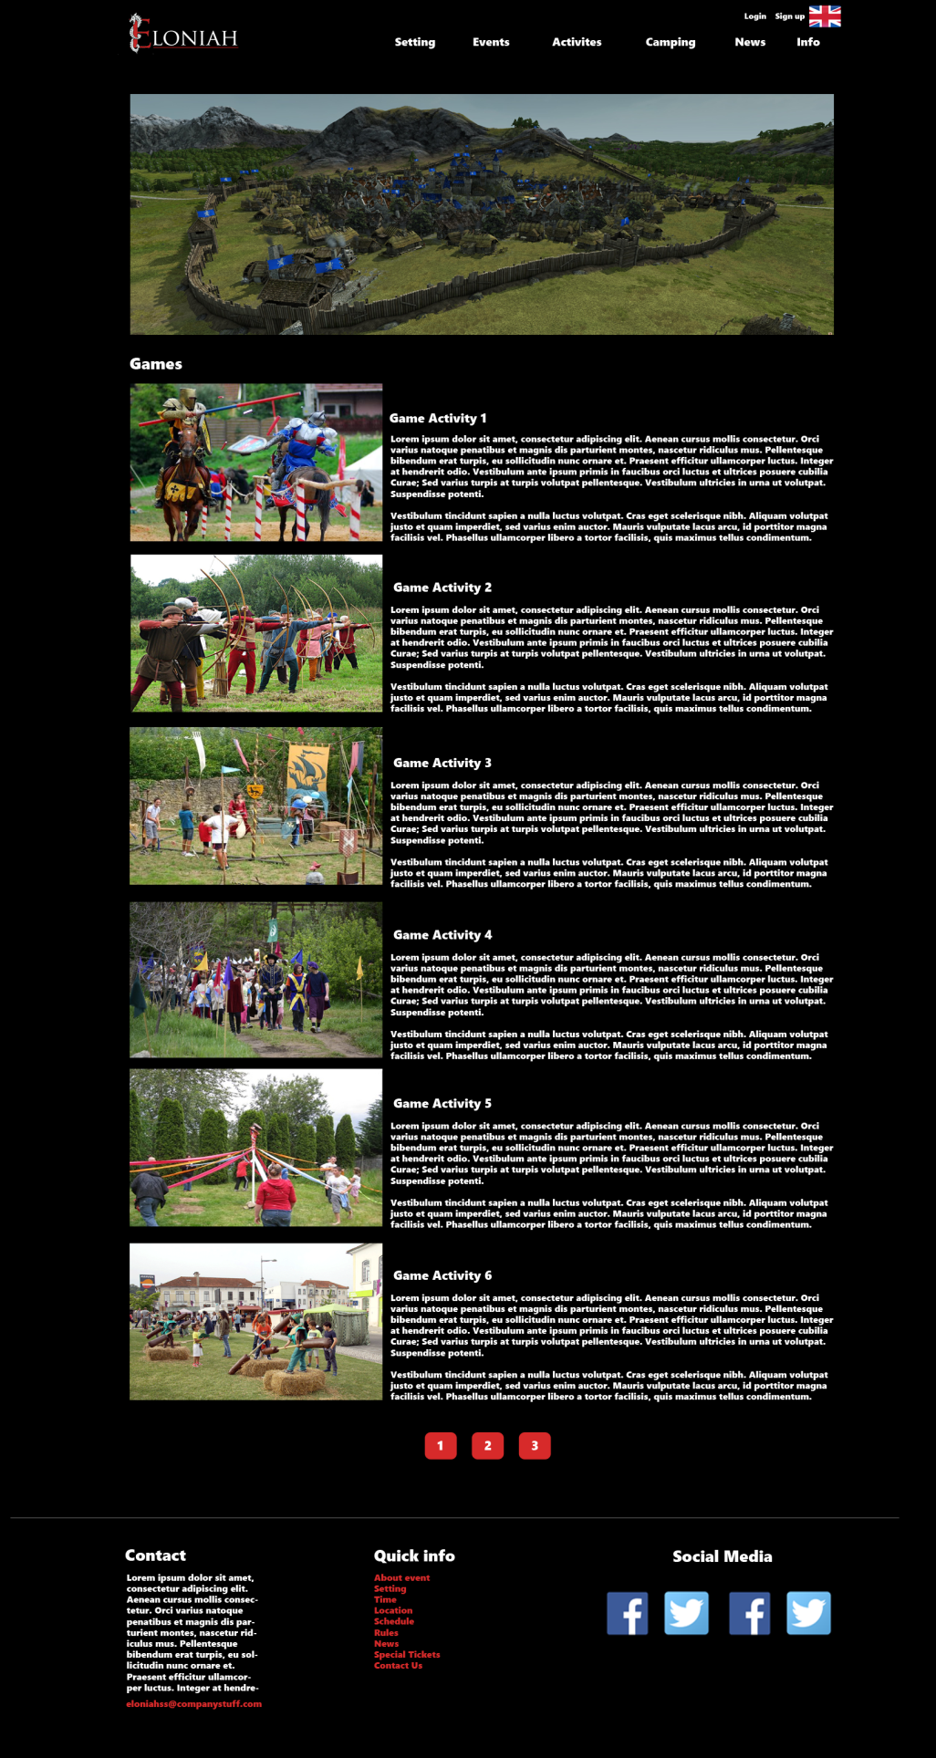

**Camping page:**

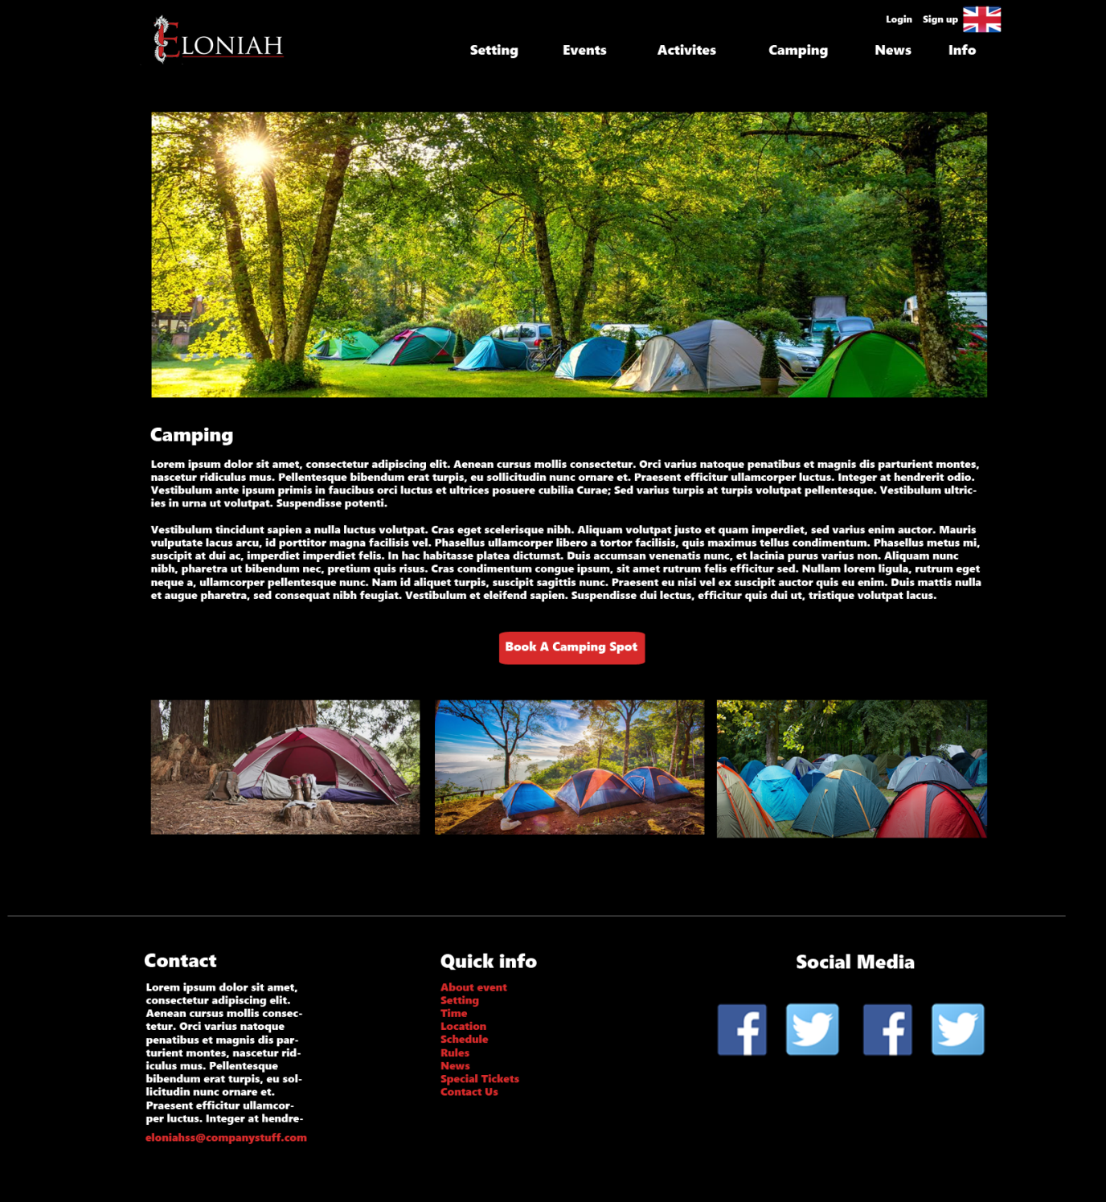

**News page:**

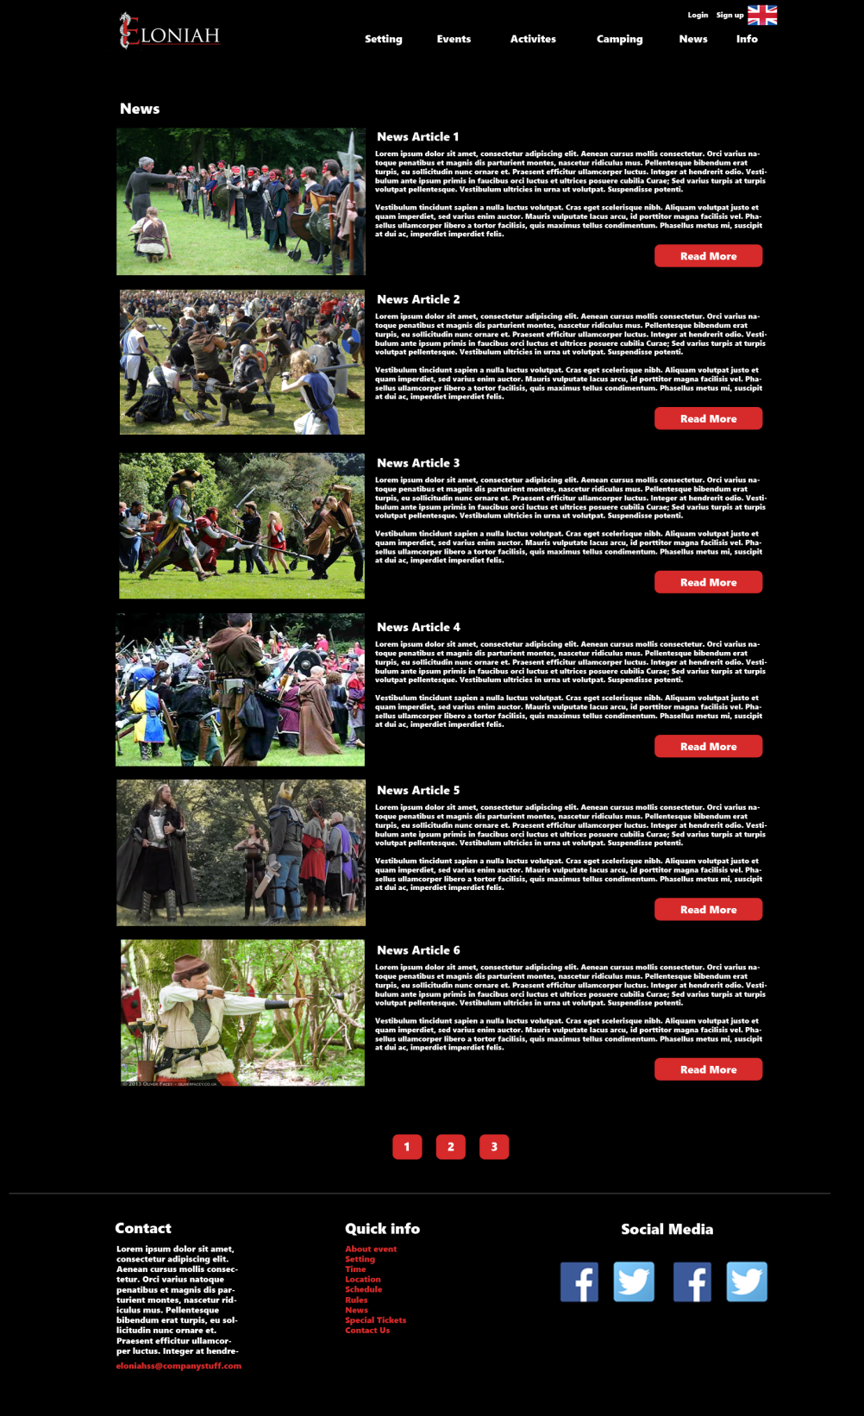

*News – read more:*

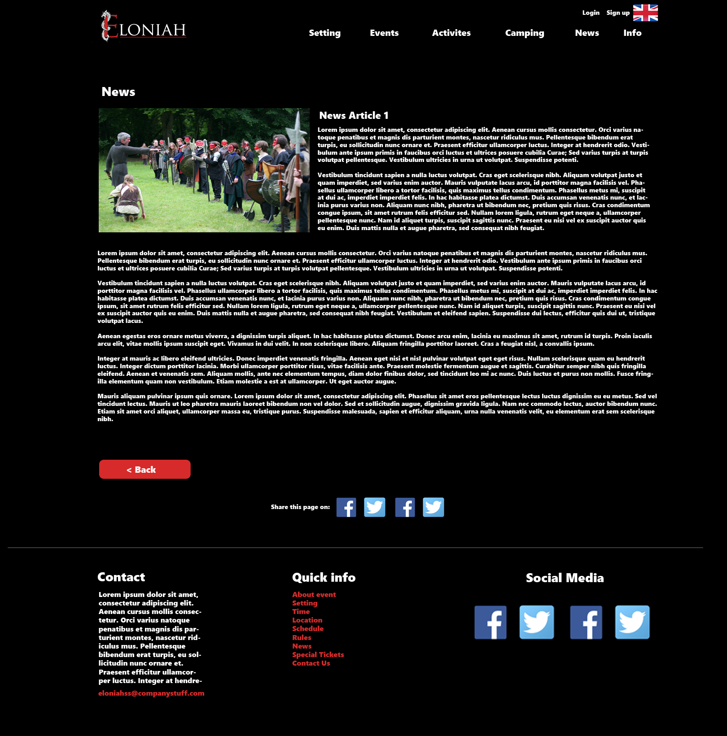

**About page:**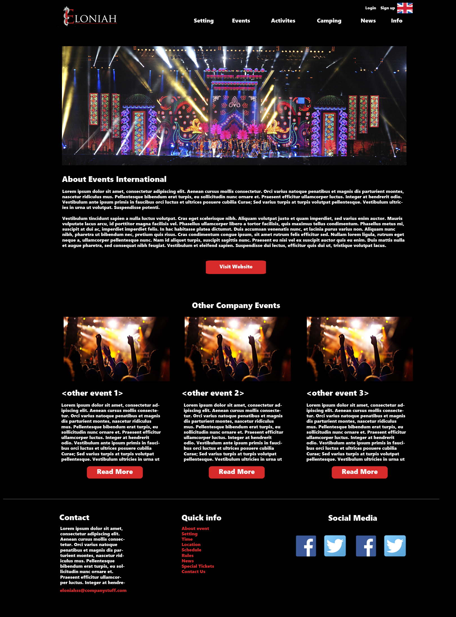

**Login page:**

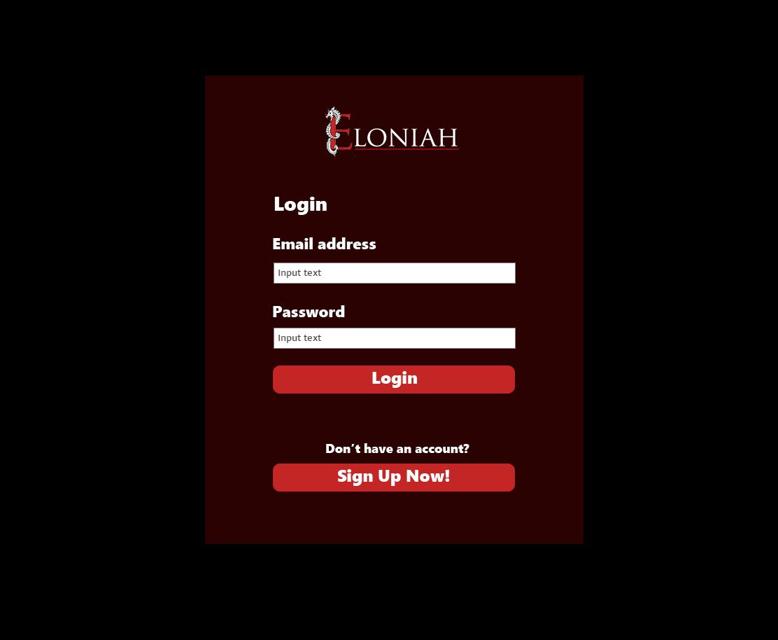

**Sign up page:**

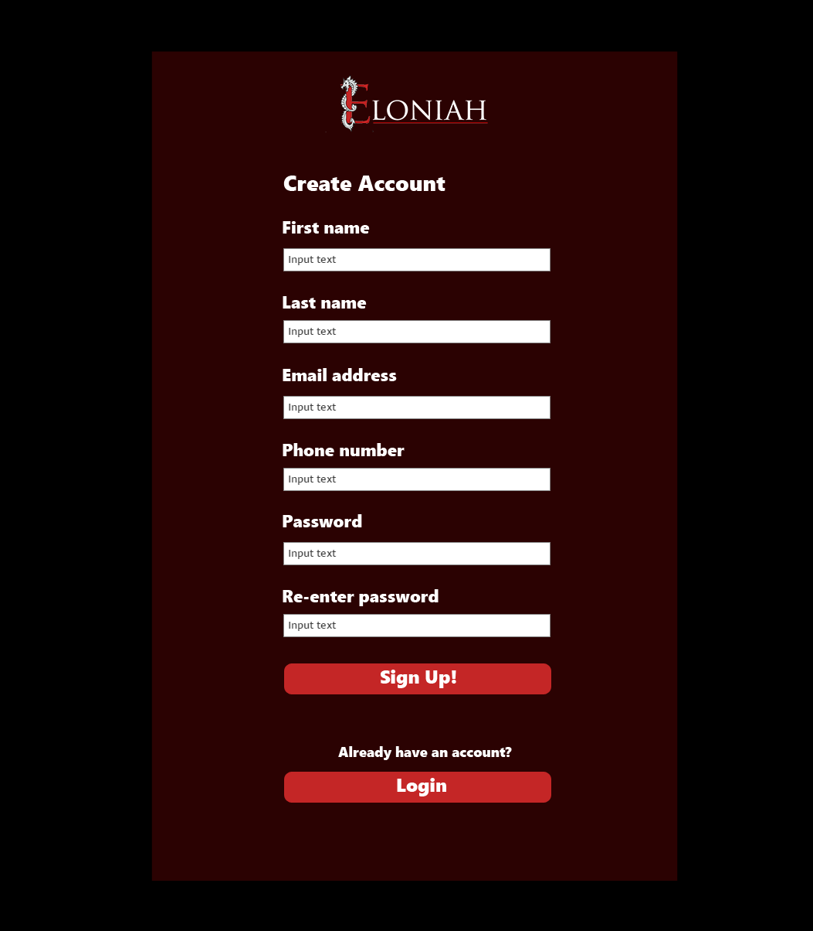

**Participant’s information page** (to show tickets information)

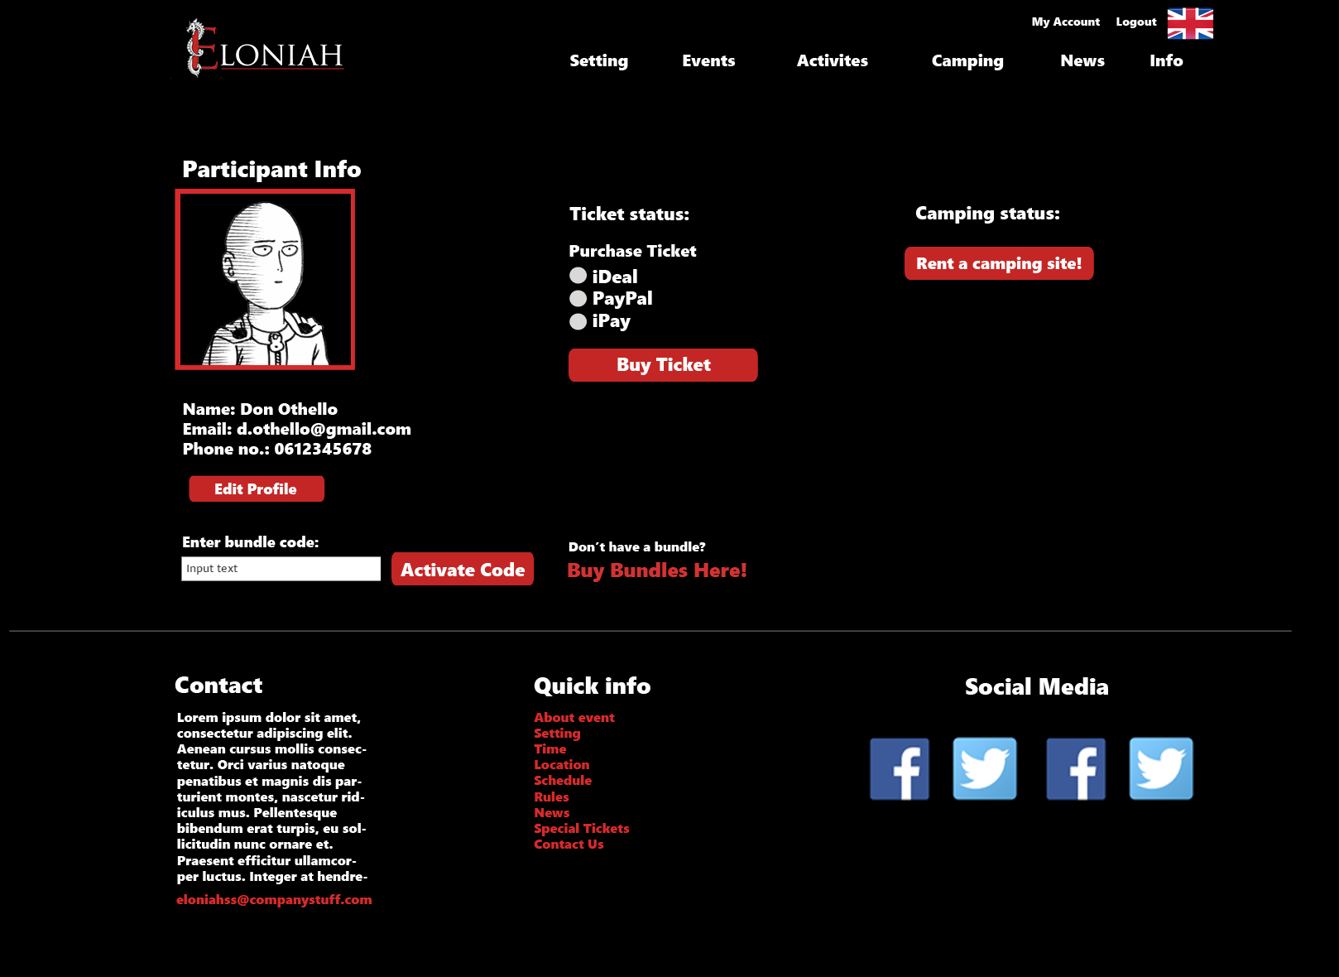

**Participant’s information page** (to show camping information)

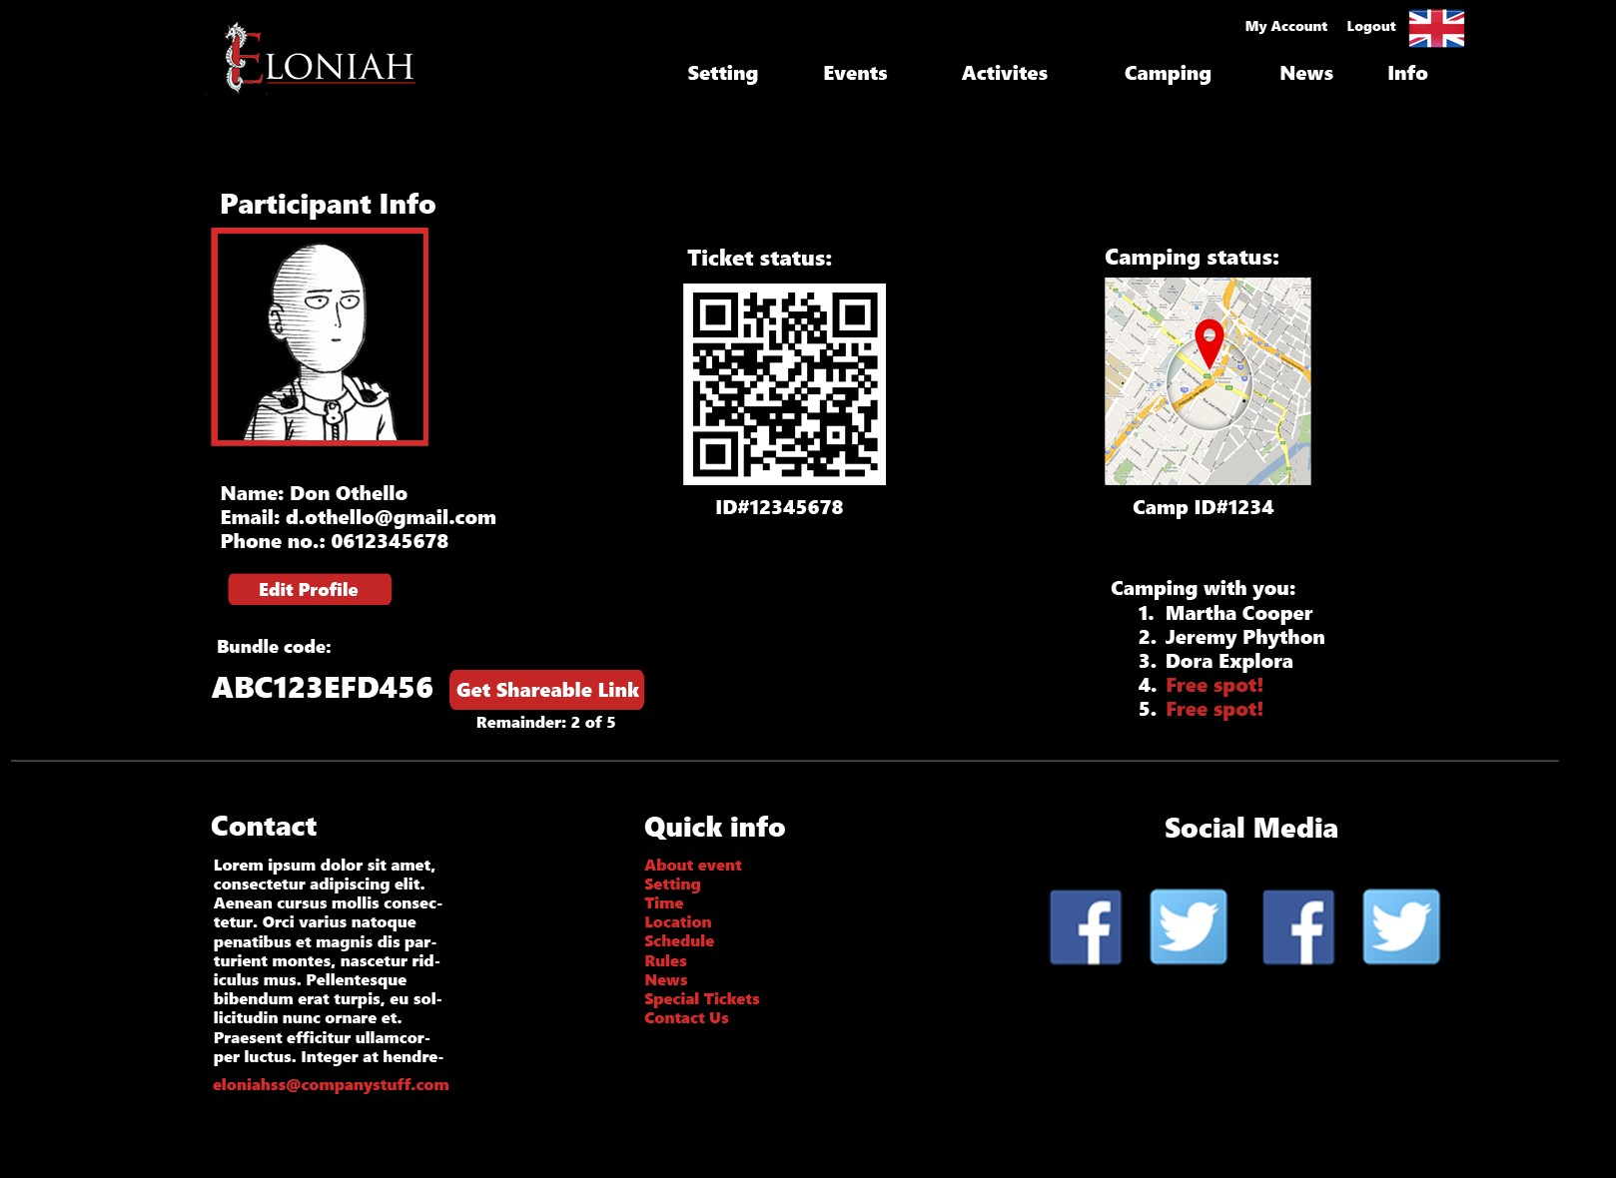

**Camping registration page:**

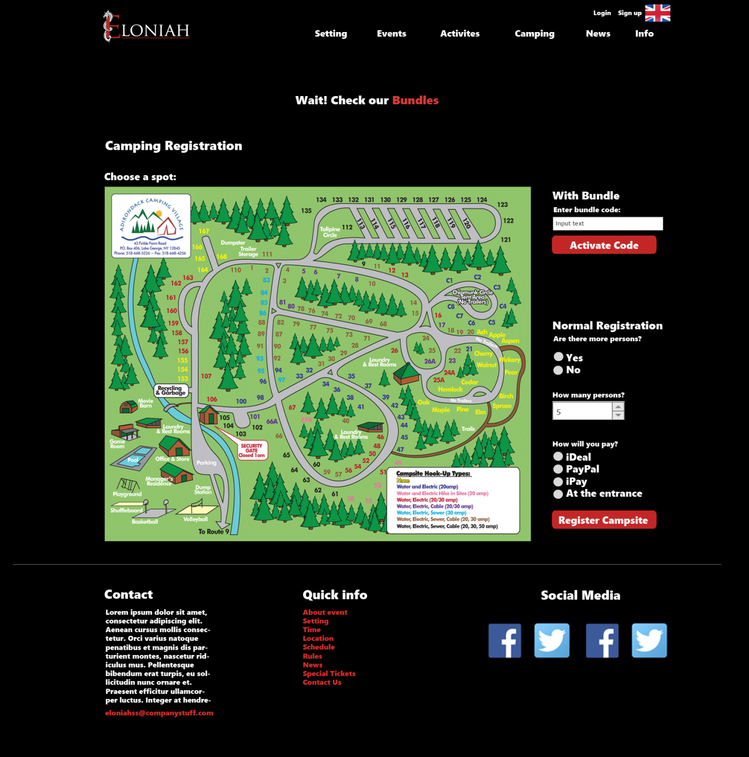

**Bundles page:**

